
Dancing City Easy Read Guide 2025
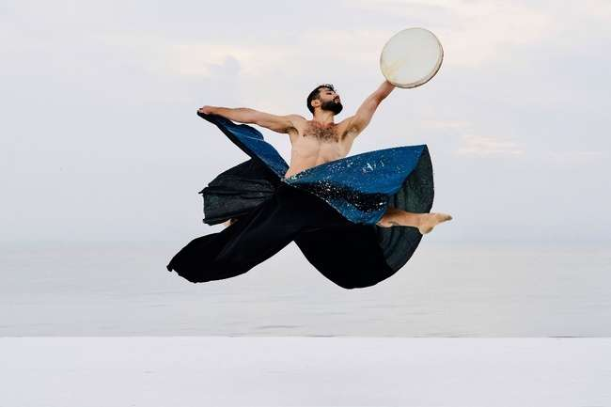
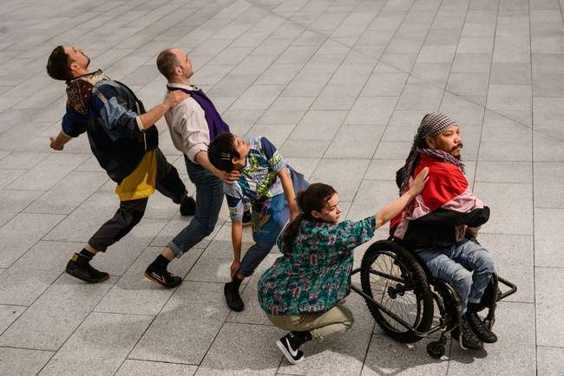

 | Welcome to Dancing City
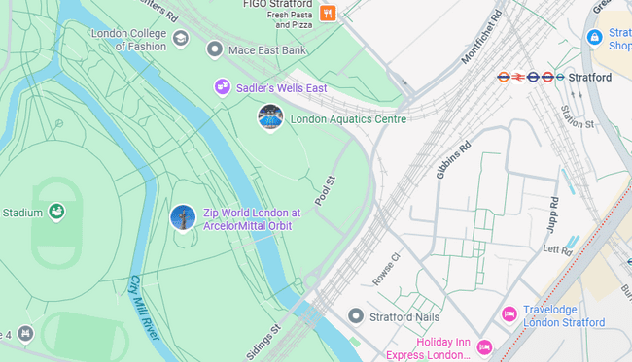 | Dance shows take place across different sites on Stratford
  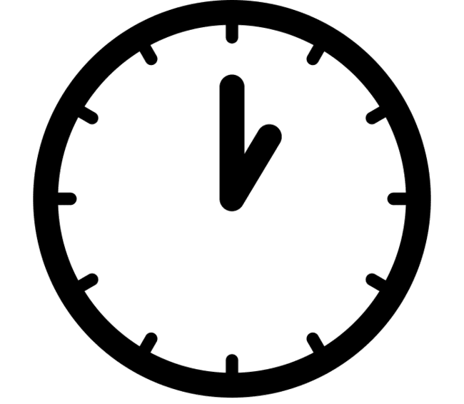 | The event date is:  Saturday 6th September  The event starts at 1pm and ends 6:30pm
 | Our theme for this year is  “Above and Beyond”

Dancing City Shows 2025
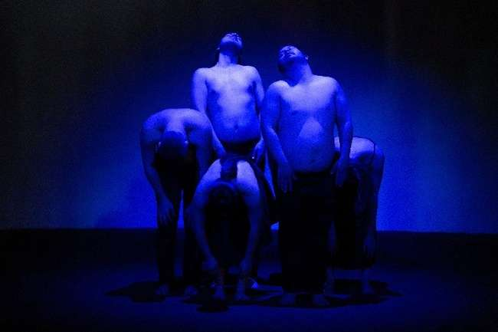 | Through Another Lens  Performed by disabled and non-disabled artists, uncovering beauty in places we rarely pause to see.  Free- just show up.  Date: Saturday 6th September  Time: 2:55pm and 5pm (17mins)  Location: Queen Elizabeth Olympic Park, Waterfront Square, E20 2AQ  For full access information:  https://festival.org/dancing-city-2025/
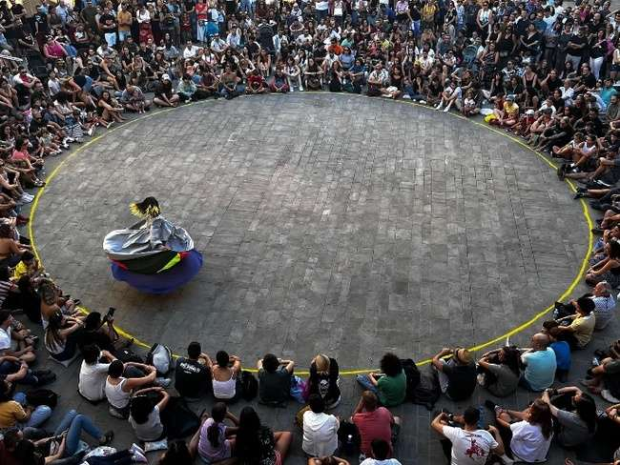 | 360  Hypnotizing dance show about womanhood and Columbian heritage, spin on rotation, over and over again  Date: Saturday 6th September  Time: 3:10pm and 4:40pm (17 mins)  Location: Queen Elizabeth Olympic Park, The Carousel, E20 2ST  For full access information:  https://festival.org/dancing-city-2025/
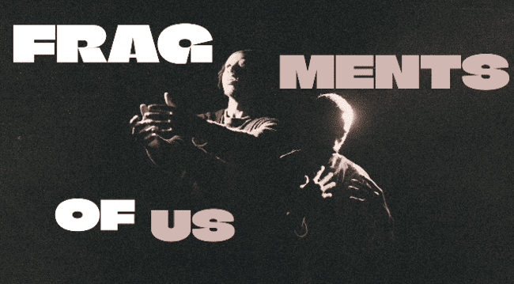 | Fragments of Us  A dance theatre piece that celebrates the endless possibilities of Black masculinity.  Date: Saturday 6th September  Time: 1pm and 3:20pm (20mins)  Location: General Gordon Pl, London SE18 6EU  For full access information:  https://festival.org/dancing-city-2025/
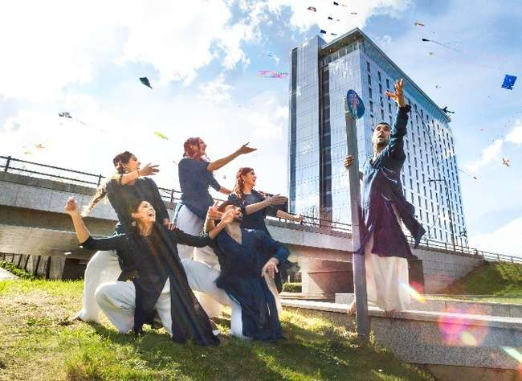 | One Sky  Bringing the India’s Kite Festivals to Stratford, filling the sky with colour and joy.  Date: Saturday 6th September  Time: 2:30pm and 5:30pm (30mins)  Location: Stratford Walk, E20 1EJ  For full access information:  https://festival.org/dancing-city-2025/
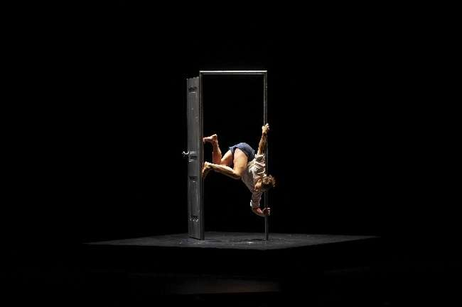 | Passage  gravity-defying performance, hypnotic movement and staging.  Date: Saturday 6th September  Time: 3:45pm, 5:10pm and 6:20pm (8mins)  Location: Fountain Square Queen Elizabeth Olympic Park, E20 2ST  For full access information:  https://festival.org/dancing-city-2025/
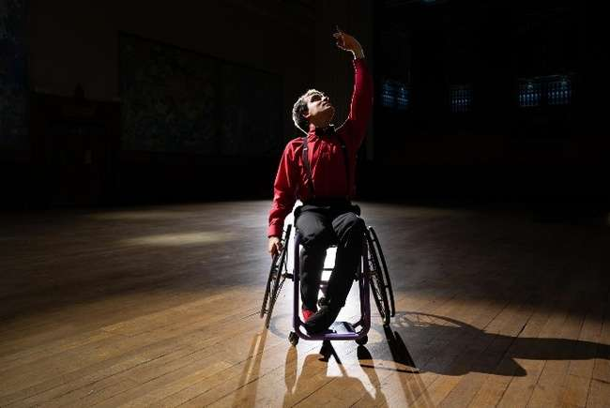 | Passionately Defiant  Mixing paso doble, tango and ballet techniques, this performance tracks Joe’s journey back to dance after becoming disabled at the age of 15.  Date: Saturday 6th September  Time: 1:55pm and 3:30pm (10mins)  Location: Marshgate South, Marshgate Building, 7 Sidings St, London E20 2AE  For full access information:  https://festival.org/dancing-city-2025/
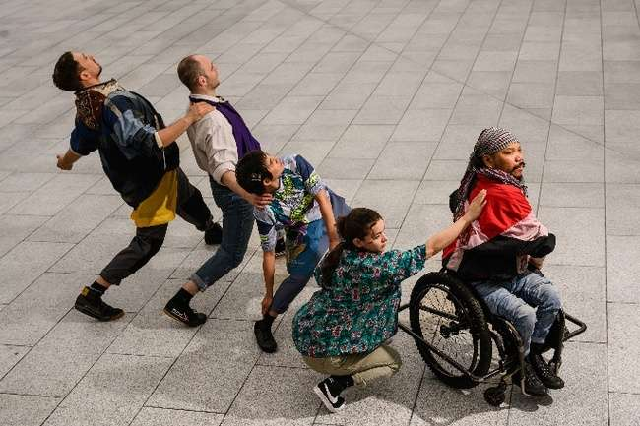 | RO-TES  Inspired by Cambodian heritage, StopGap reimagines the wheelchair as a place that can support more that just a body.  Date: Saturday 6th September  Time: 1pm and 4pm (15mins)  Location: Marshgate South, Marshgate Building, 7 Sidings St, London E20 2AE  For full access information:  https://festival.org/dancing-city-2025/
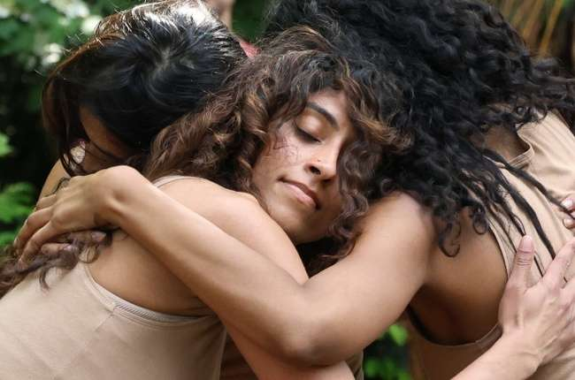 | Roots to Rise  Three women confront their personal and histories, learning from one another and those who came before  Date: Saturday 6th September  Time: 2:15pm and 5:30pm (30mins)  Location: Queen Elizabeth Olympic Park The Carousel, E20 2ST  For full access information:  https://festival.org/dancing-city-2025/
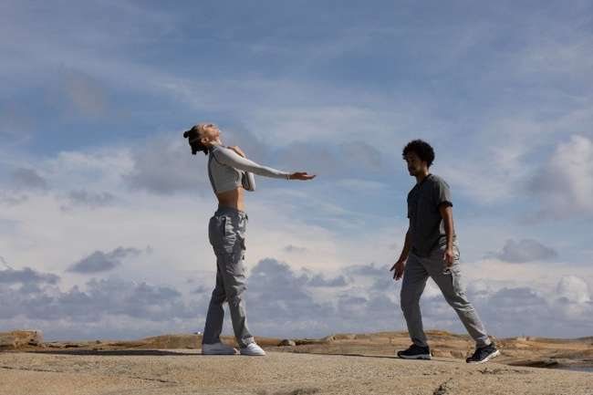 | WaterKind  Combining freestyle and popping, this movement connects two bodies without direct physical contact.  Date: Saturday 6th September  Time: 1:35pm and 4:05pm (26mins)  Location: Carpenters Lock, Queen Elizabeth Olympic Park, E20 2ST  For full access information:  https://festival.org/dancing-city-2025/
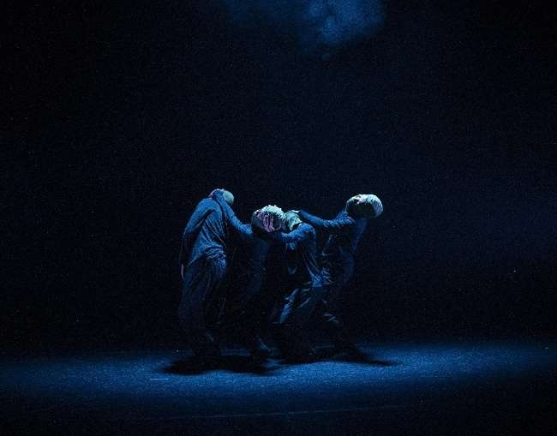 | Jungle Boy  A dance piece exploring identity, connection, and mental health  Date: Saturday 6th September  Time: 2pm and 4:15pm (17mins)  Location: Queen Elizabeth Olympic Park, East Bank Waterfront, E20 2AQ  For full access information:  https://festival.org/dancing-city-2025/
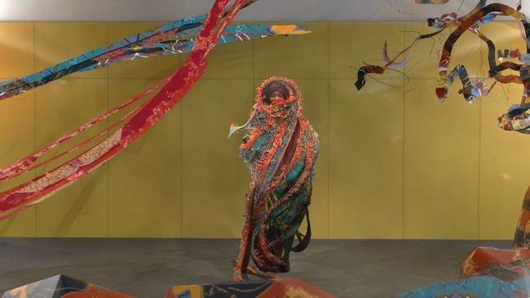 | Whispering Forest  VR experience of a Yoruba tale danced and spectacular textiles  Date: Saturday 6th September  Time: 1pm and 3pm (7mins)  Location: Inside UEL (London College of Fashion) University Way, London E16 2RD  For full access information:  https://festival.org/dancing-city-2025/
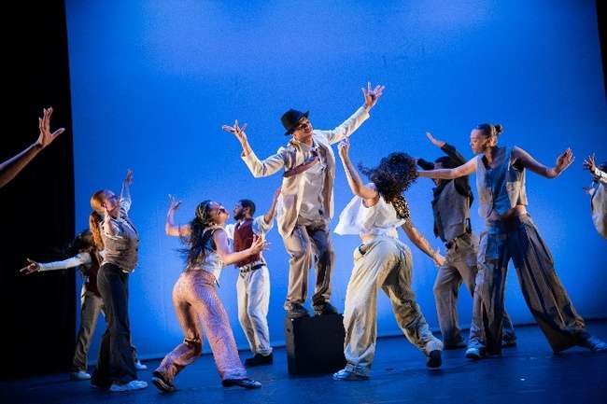 | When Jazz Meets Hip Hop  Jade Hackett explores the connection between jazz music and hip-hop culture  Date: Saturday 6th September  Time: 1:30pm and 3pm (7mins)  Location: Theatre Square Rooftop, Theatre Square, Stratford. E151BX  For full access information:  https://festival.org/dancing-city-2025/
Fire Island
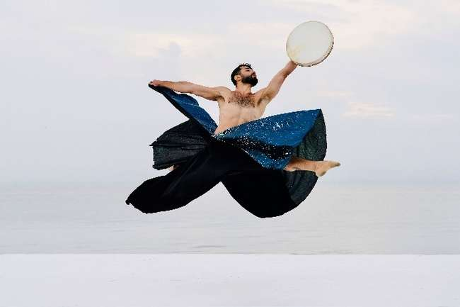 | Layl “Night”  Solo performance inspired by Sufi Whirling Dervishes  Date: Saturday 6th September  Time: 1pm and 3:30pm (25mins)  Location: Queen Elizabeth Olympic Park, East Bank Waterfront, E20 2AQ  For full access information:  https://festival.org/dancing-city-2025/
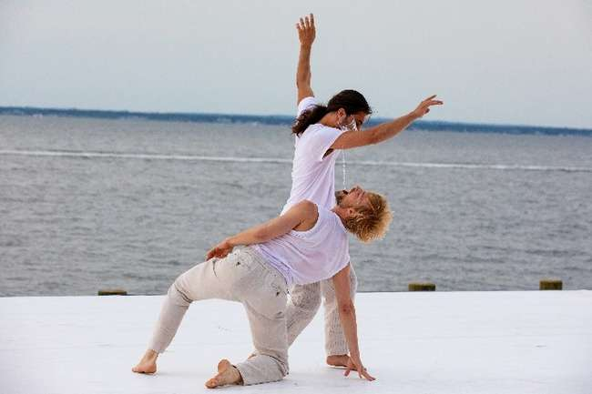 | A Delicate Balance  A duet exploring themes of trust and human connection.  Date: Saturday 6th September  Time: 1pm and 3:30pm (25mins)  Location: Queen Elizabeth Olympic Park, East Bank Waterfront, E20 2AQ  For full access information:  https://festival.org/dancing-city-2025/
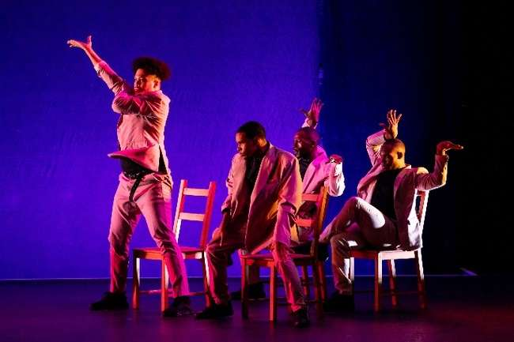 | Courtney’s Diner  Contemporary dance and New York City’s ballroom scene come together in energetic movement  Date: Saturday 6th September  Time: 1pm and 3:30pm (25mins)  Location: Queen Elizabeth Olympic Park, East Bank Waterfront, E20 2AQ  For full access information:  https://festival.org/dancing-city-2025/

Access
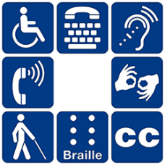 | GDIF welcomes all and aims to be accessible to everyone.
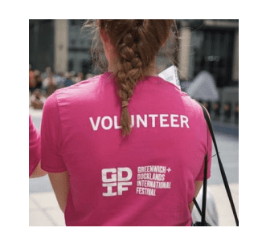 | Our friendly staff and volunteers are there to help.  They will be wearing pink t-shirts.
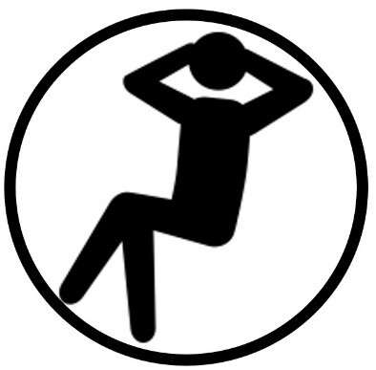 | All shows and sites are relaxed.  You are welcome to:  ・Move around – just not on stage.  ・Make noise  ・Join and leave at any time  We have a low sensory area on site. This is somewhere away from noise and crowds.
       | Access on site:  All shows are wheelchair accessible.  We welcome Assistance Dogs.  Viewing areas with chairs will be available.  Accessible toilet and blue badge parking information is available on our website.
    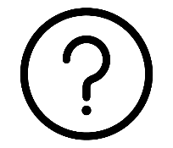 | Some shows will have digital or live audio description  Easy Read is available via QR codes, and also at our Access Areas.  Most shows are Speech Free  There will be suggested routes to help you plan your day on our website  https://festival.org/dancing-city-2025/
   | For more information  Contact: Evie Ayres-Townshend  Website: https://festival.org/gdif/access/  E-mail: access@festival.org  Phone: 07899 893 935

Support GDIF
 | We would be grateful if you would consider donating to GDIF.
 | You can do this by visiting:  bit.ly/supportGDIF

Photography and filming
   | We have photographers and film makers at events to capture footage to share online and for use in future.  If you don’t want to have your photo taken, please wear a ‘No Photography’ sticker, available from our volunteers.  Got some great photos you want to share? Tag us @GDIFestival and use #GDIF2025.

