Fire Island
at Dancing City

Visual Guide

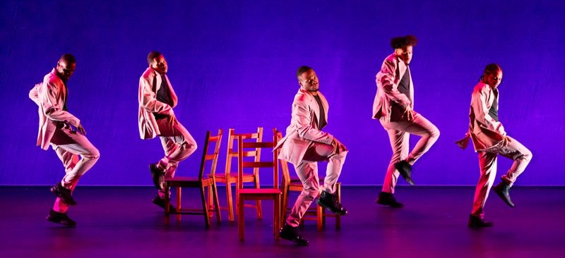
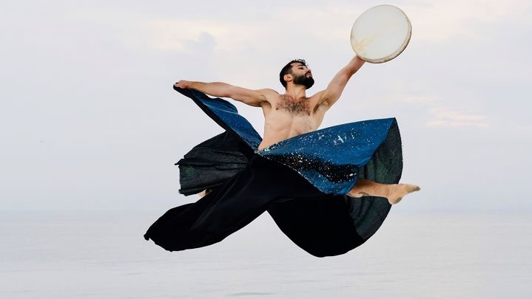
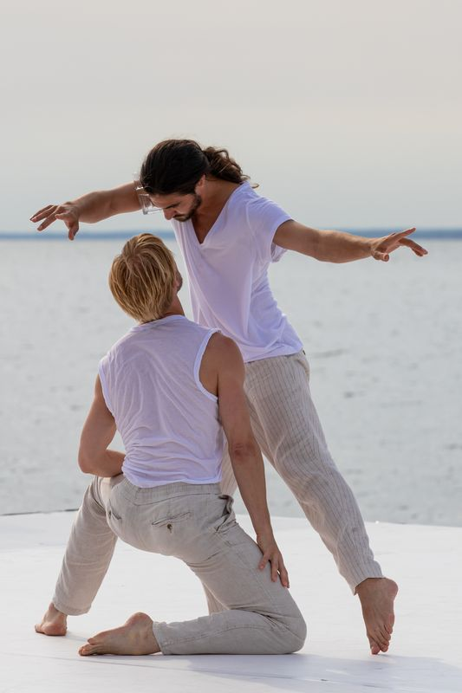

3 images of 3 Fire Island performances: a solo male dancer, a male duet and a male quintet.

What to Expect

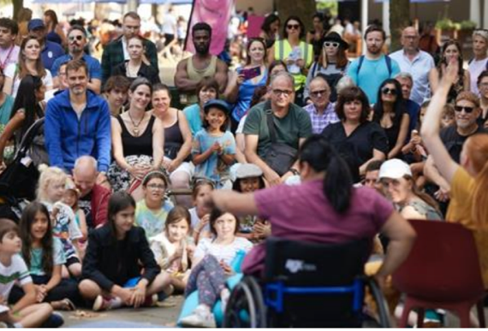 | Who is it for?  This show for everyone
 | Dates and Times:  6th September  1pm, 3:30pm, 6:05pm
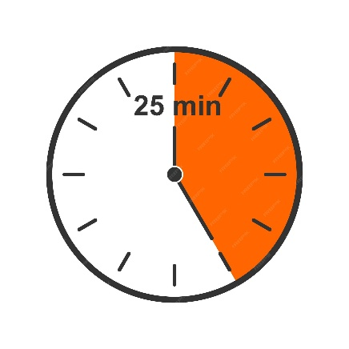 | Length of show:  Layl: 5 minutes  Courtney’s Diner: 5 minutes  A Delicate Balance: 17 mins  27 minutes
   | Access:  - Speech Free
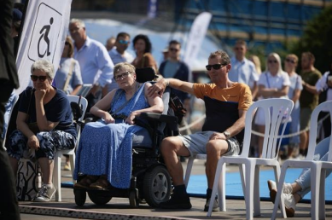 | Access Viewing Area for:  - Wheelchair users.  - Anyone who needs a seat.  - Companions.  - Anyone who needs it for access reasons.
 | Music and Sound:  The music is a backing track
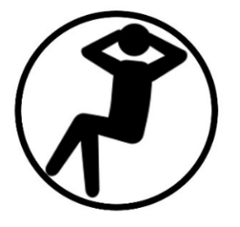 | You are welcome:  - Move around – just not on stage  - Make noise  - Join and leave at any time
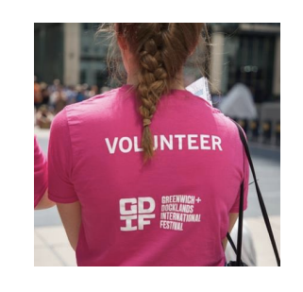 | Volunteers:  Friendly volunteers are there to help.  They will be wearing pink t-shirts.

About Fire Island at Dancing City

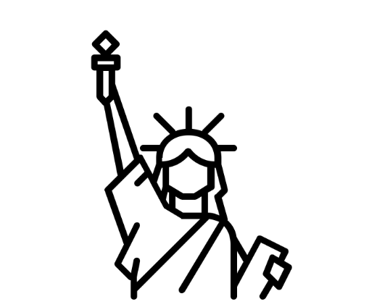 | Fire Island is a queer performance festival in New York  They are bringing 3 performance to Dancing City.
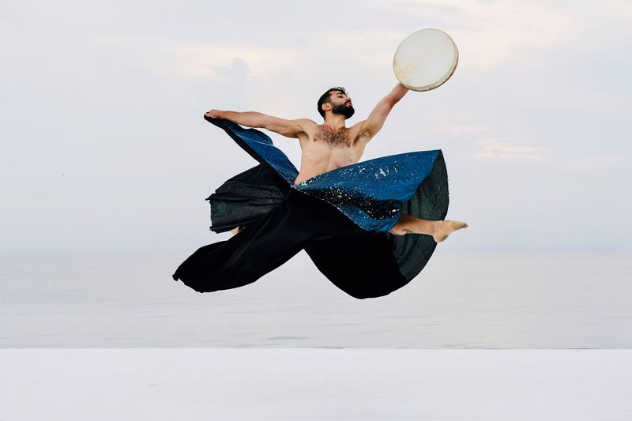 | ‘Layl by Ahman Joudeh  Solo male performer in traditional Sufi skirt performing to Syrian music.
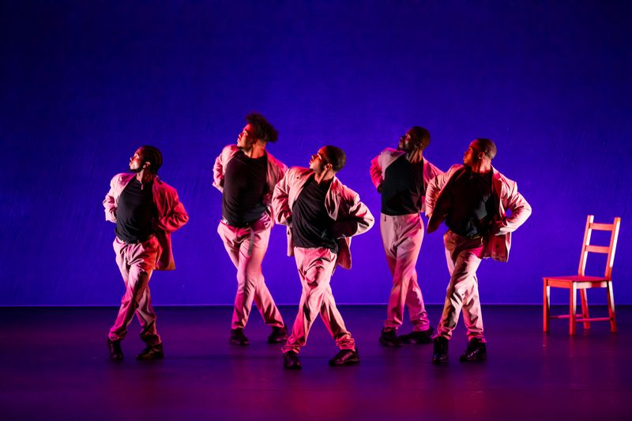 | Courtney’s Diner - Courtney Washington Balenciaga and Masterz at Work Dance Family  5 male dancers perform a high energy hip hop routine
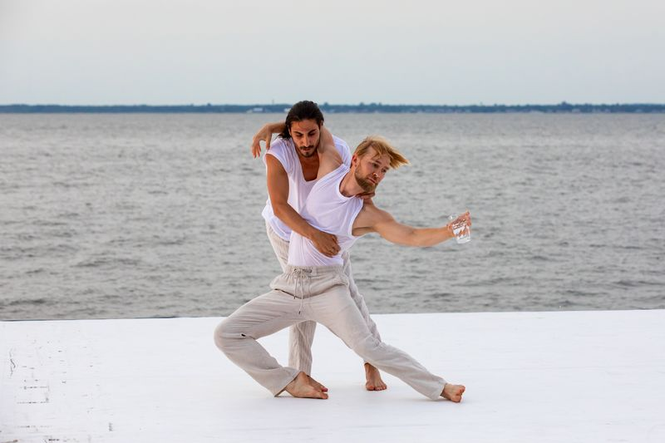 | A Delicate Balance by Pontus Lidberg  A male duet, balancing a glass of water between them.

Creative team

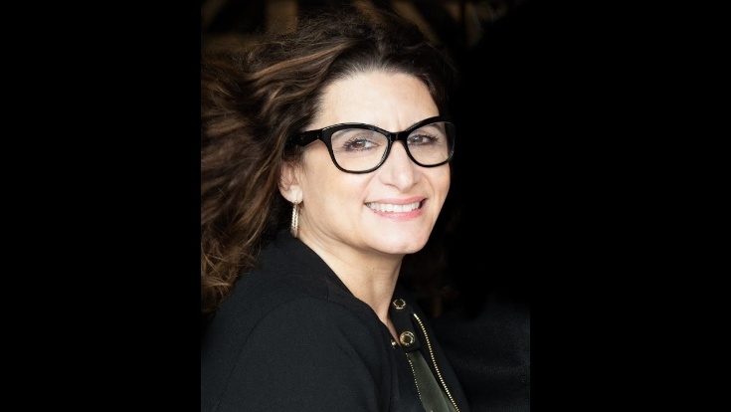 | Denise Roberts Hurlin, Founding Director, FIDF, DRA
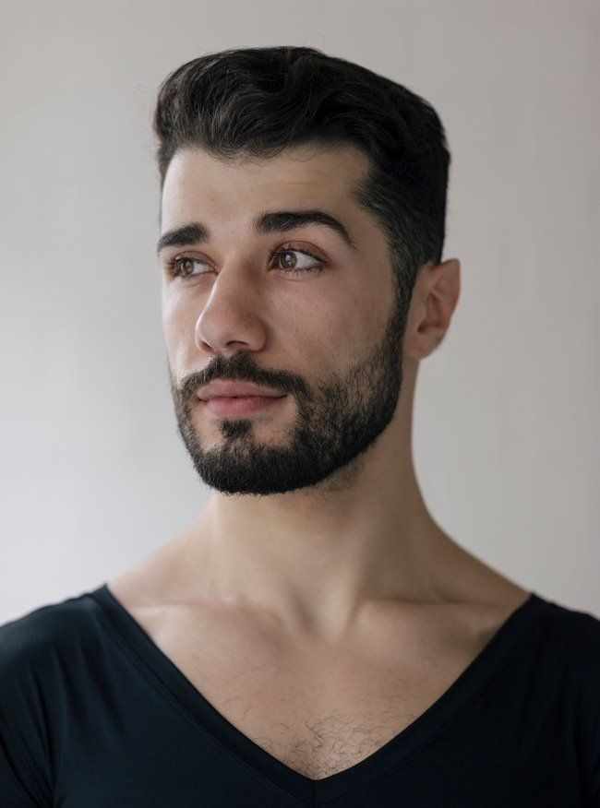 | Ahmad Joudeh (Layl)
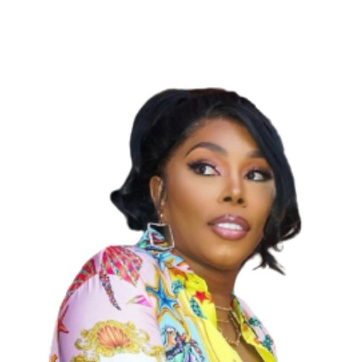 | Courtney Washington (Courtney’s Diner)
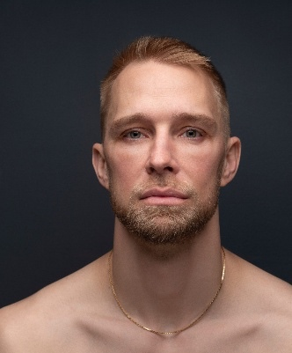 | Pontus Lidberg (A Delicate Balance)

Find out more

 | Info about the company:  https://dradance.org/  https://www.ahmadjoudeh.com/  https://www.pontuslidberg.com/  https://www.instagram.com/_masterzatwork/?hl=en
 | Contact:  Email: access@festival.org  Call or text: 07899 893 935

