Fire Island Triptych, Jungle Boy Dancing City- Eastbank Waterfront
Route from Stratford Station
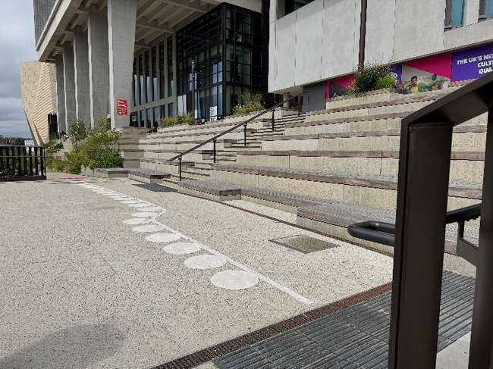 | Address:  Queen Elizabeth Olympic Park,  East Bank Waterfront, E20 2AQ  What 3 words:  http://what3words.com/pack.like.goods
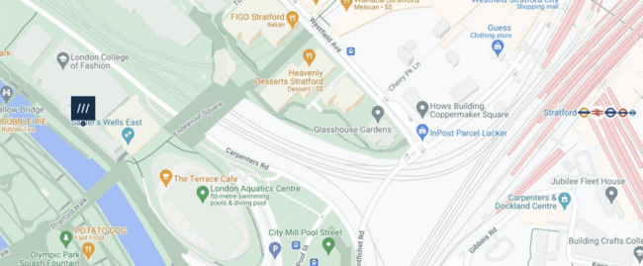
 | Transport  Stratford Station and Bus Station
 | Plan Your Journey:  Visit www.tfl.gov.uk
Route from Stratford Station, Montfichet Road (Westfield Exit)
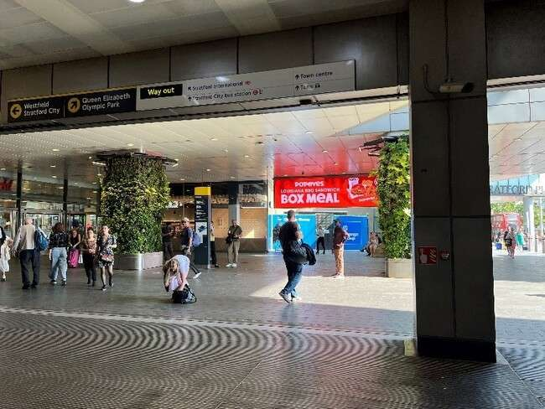 | Exit Stratford Station onto Montfichet Road (Westfield Exit)
 | Use the lift, stairs or escalators opposite the station exit to get to level 1.
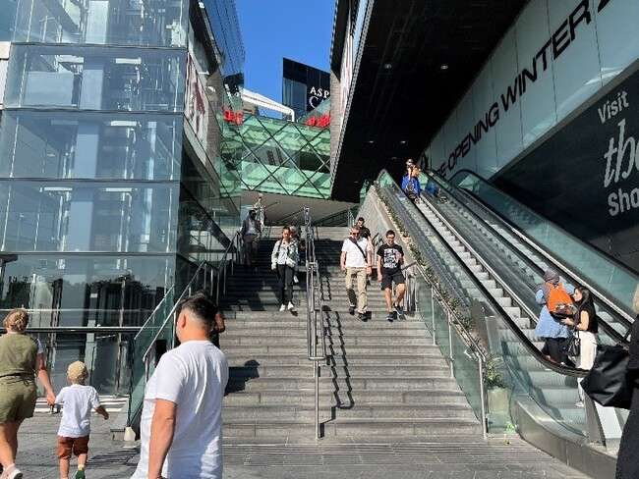
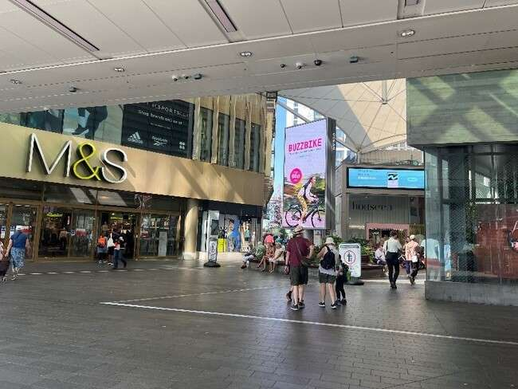 | Turn into Westfield shopping center and walk past M&S on your left.
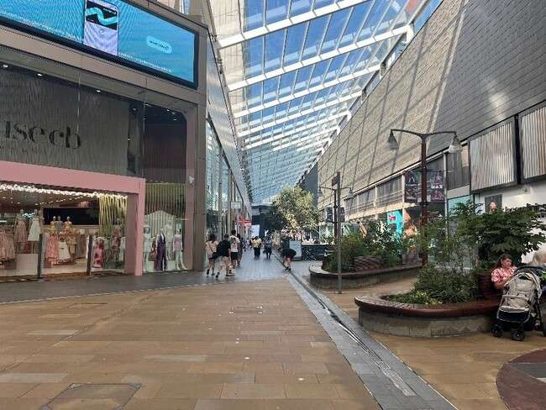 | Continue down the covered avenue of shops.
 | Exit the covered area and turn left past the restaurants and covered seating.
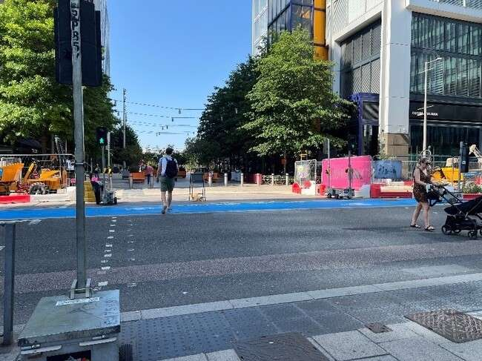 | Cross Westfield Avenue and continue straight on.
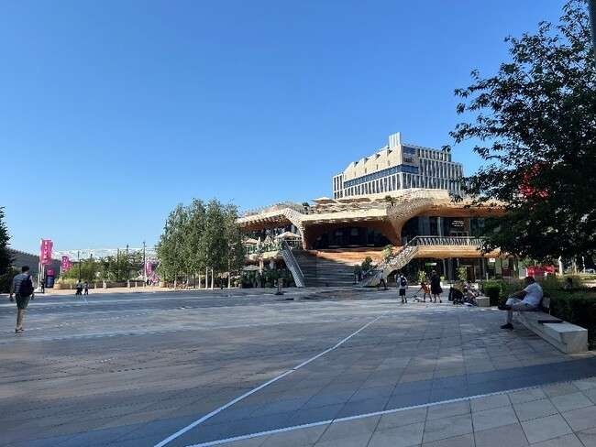 | Continue straight through  Stratford Cross on Stratford Walk.
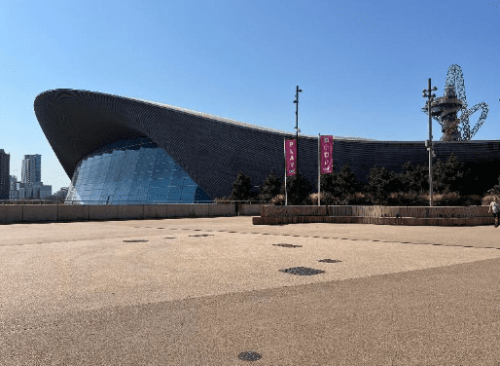 | Pass the Aquatics Centre on your  left on Stratford Walk.
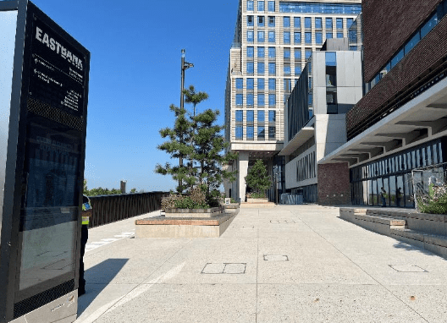 | Before the bridge that crosses the river turn right onto Eastbank  Waterfront.
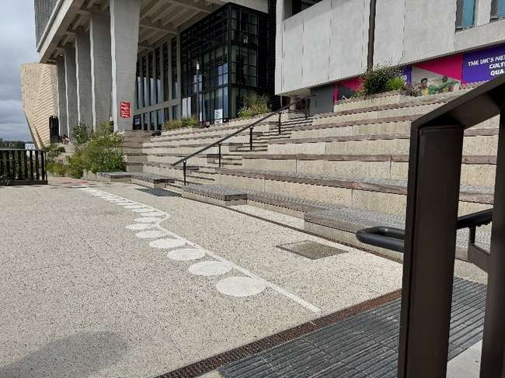 | The site will be directly in front of  you.

