Fragments of Us and Go Grandad Go - General Gordon Square
Route from Woolwich Station Elizabeth Line via Woolwich Arsenal Station
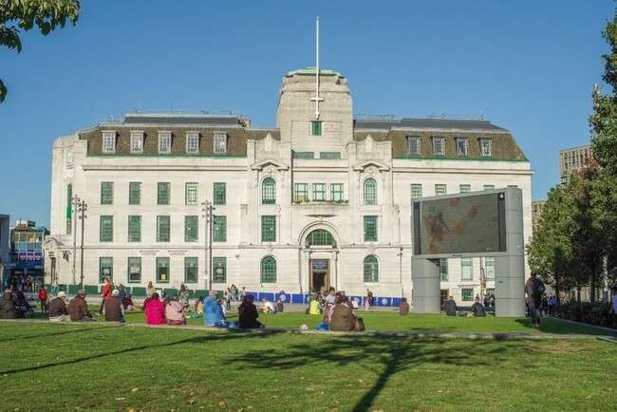 | Address:  General Gordon Pl, London SE18 6EU  What 3 Words:  ///fable.teaches.knives
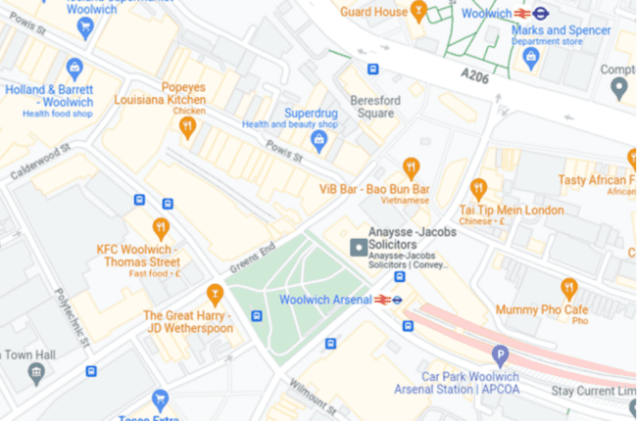
 | Transport  Train:  Woolwich station  Woolwich Arsenal DLR  Buses:  161, 178, 386, 122, 244, 291, 469, 51, 53, 54, 96, 99, 177, 180, 301, 380, 422, 658
 | Plan Your Journey:  Visit www.tfl.gov.uk to plan your journey.

Route from Woolwich Station Elizabeth Line
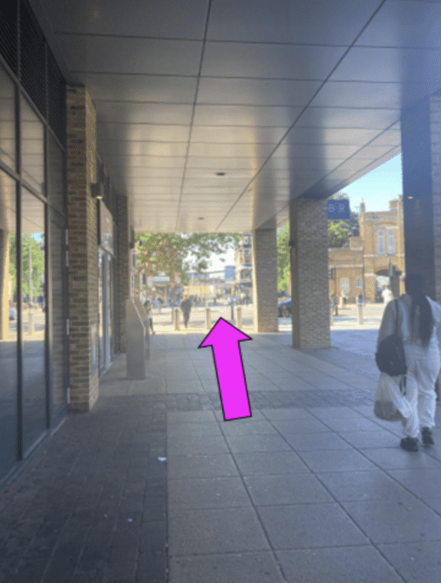 | When you exit the station, turn left and head towards Plumstead Road.
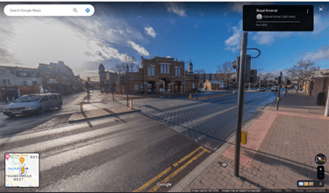 | Cross Plumstead Road at the crossing.
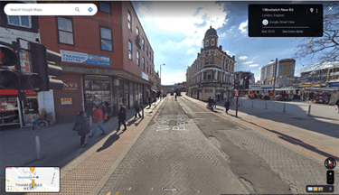 | Head down Woolwich New Road.
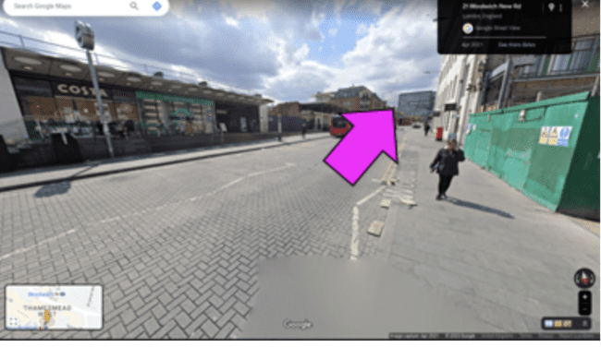 | Continue down Woolwich New Road. You will pass Woolwich Arsenal Station on your left.
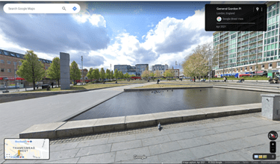 | Continue down Woolwich New Road. General Gordon Square will be on your right.  Volunteers will be there to direct and assist you.

Route from Woolwich Arsenal Station
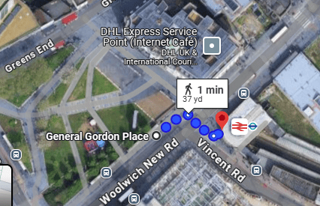
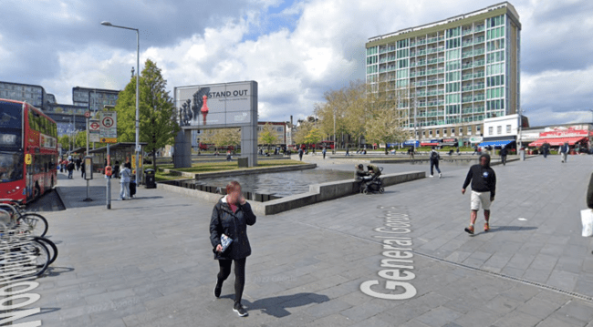 | When you exit the station, cross over the road General Gordon Square will be in front of you  Volunteers will be there to greet you

