Fragments of Us
by Talawa Theatre Company

Visual Guide

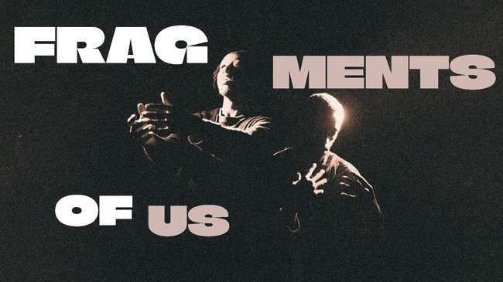

Centred around a cast of Black boys and men, this intimate production explores themes of identity, resilience, vulnerability, and the beauty of shared experience

What to Expect

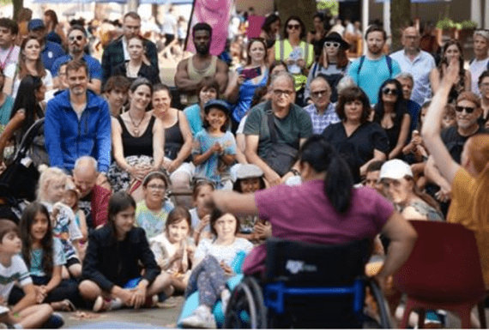 | Who is it for?  This show is suitable for all ages
 | Dates and Times:  General Gordon Square, Woolwich:  4th September 2025 – 4pm+ 6:30pm  Dancing City:  6th September 2025 – 1pm & 3:20pm
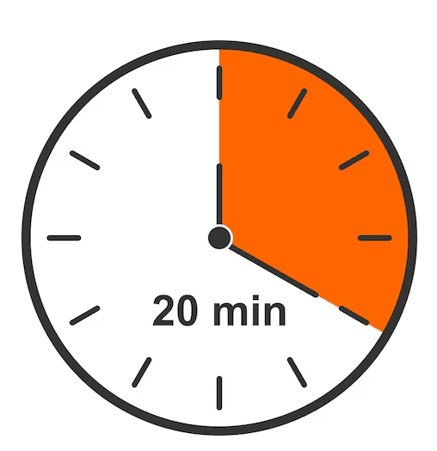 | Length of show:  25 min
   | Access:  - Live AD 4th September 6:30pm  - Easy Read Information  - QR codes for any poetry
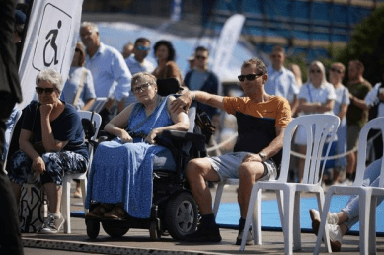 | Access Viewing Area for:  - Wheelchair users.  - Anyone who needs a seat.  - Companions.  - Anyone who needs it for access reasons.
 | Music and Sound:  Music and sound info
 | Content  The performers jump over the barriers and move the barriers around. They have rehearsed this.  There is a water pistol fight, you will have to move out of the way if you don’t want to get wet. It will look chaotic, it is a bit, but the performers know what they’re doing.  The performers may ask you to move where you are standing. They may do it by moving the barriers or gesturing or asking you directly. It’s part of the show
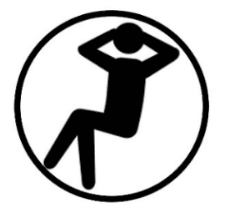 | You are welcome:  - Move around  - Make noise  - Join and leave at any time  - Join in the procession of dancing
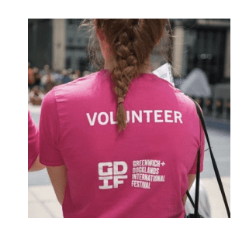 | Volunteers:  Friendly volunteers are there to help.  They will be wearing pink t-shirts.

About Fragments of Us

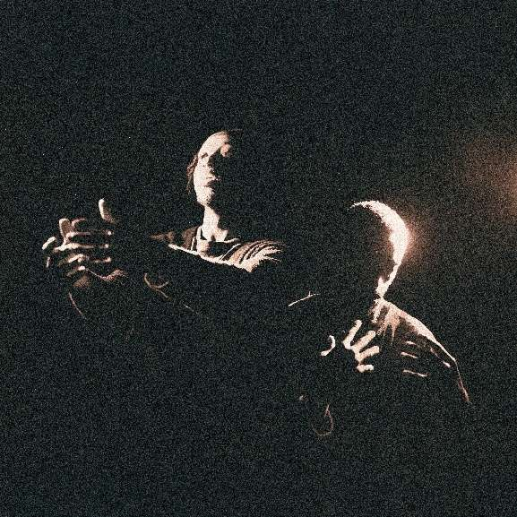 | "Fragments of Us" is an outdoor performance of dance and spoken word.  There is a cast of Black boys and men, exploring themes of identity, resilience, vulnerability, and the beauty of shared experience.
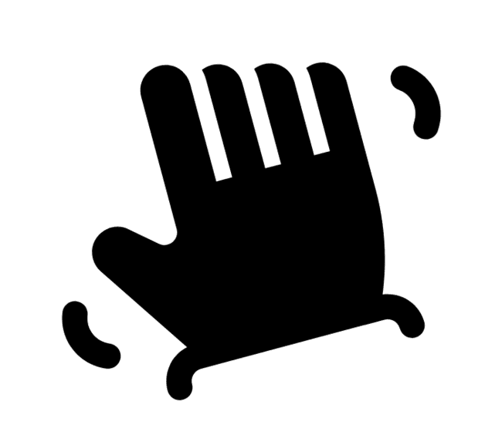 | The dancers invite moments of interaction with some audience members
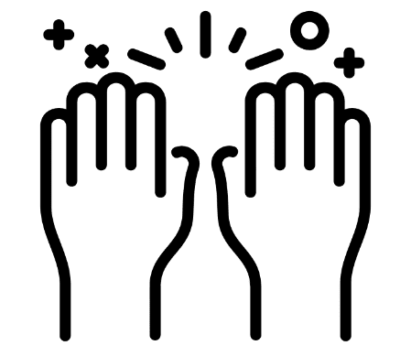 | "Fragments of Us" celebrates the strength of brotherhood and the collective history that shap es their identities.

What happens in the show – Fragments of Us

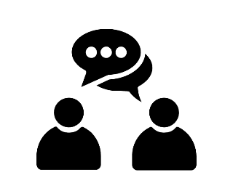  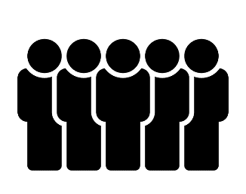  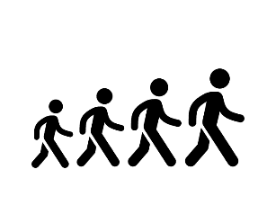  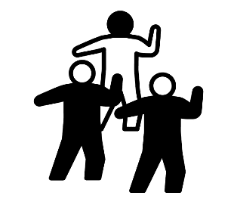 | Five young men have a water pistol fight, they run through and around the audience.  They individually talk to members of the audience close up.  One of them is wearing a big ‘spirit’ costume.  They make a procession through the audience  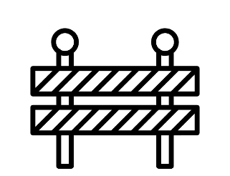  The barriers are moved . The performers dance between and over the barriers.  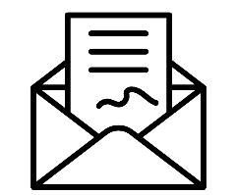  The performers find individuals in the audience to read letters to.  The performers dance between and over the barriers. The procession begins again, the audience can join in.

Creative team

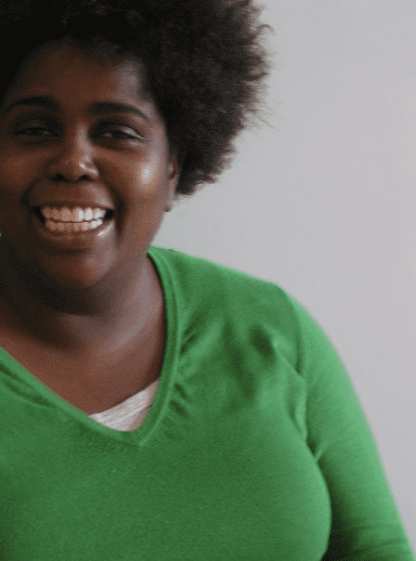 | Sonia Hughes – Lead Creative
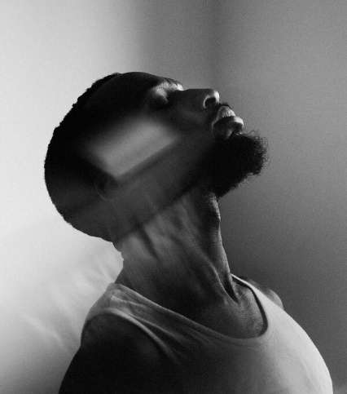 | Rhys Dennis – Lead Creative
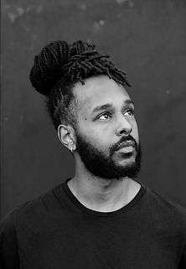 | Waddah Sinada – Lead Creative
 | Rosie Elnile – Set & Costume Designer
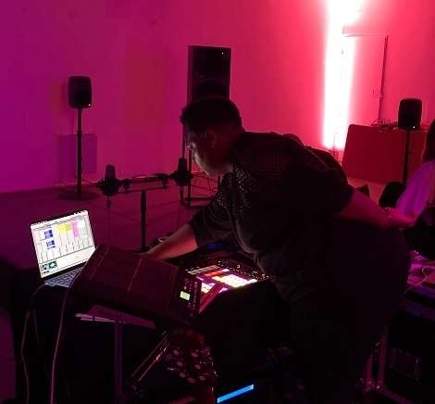 | Mwen – Sound Designer

Find out more

 | Info about the company:  Sonia Hughes is an artist who works in live art and contemporary theatre.  Fubunation (Waddah Sinada & Rhys Dennis) are choreographers of contemporary dance.
 | Contact:  Evie Ayres-Townshend (Access Producer)  Email: access@festival.org  Call or text: 07899 893 935

