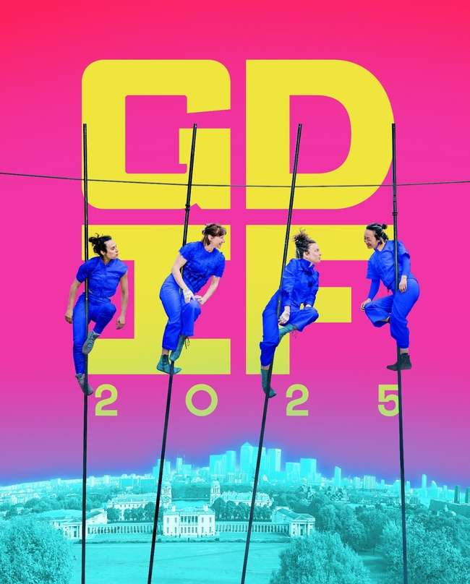

 | Welcome to Greenwich Fair, a fun family-friendly event.
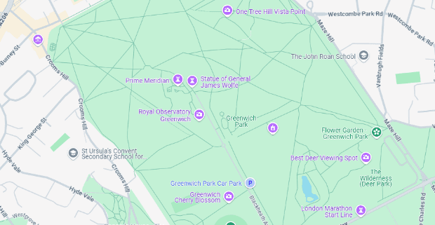 | Events take place across different sites on Observatory Hill in Greenwich Park.
 | Saturday 23rd & Sunday 24th August  1pm-7pm
 | Our theme for this year is  “Above and Beyond”

Greenwich Fair Shows 2025
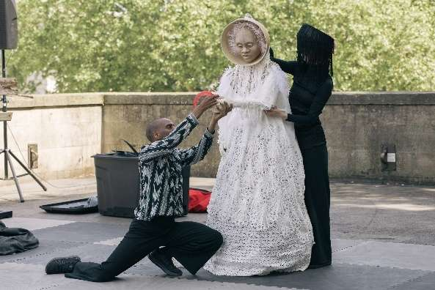 | Eshu At The Crossroads  A tale of choice, trickery and joy, with puppetry, dance and music.  Free- just show up.  Date: Saturday 23rd & Sunday 24th August  Time: 2:10pm and 5:45pm (30mins)  Location: General Wolfe Piazza  For full access information:  https://festival.org/gdif/whats-on/eshu-at-the-crossroads/
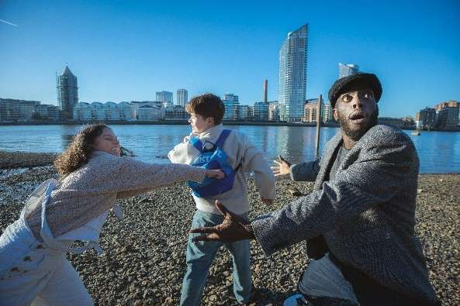 | Go Grandad, Go!  A heart-warming Caribbean story told through Hip-Hop and audience participation.  Date: Saturday 23rd & Sunday 24th August  Time: 2pm and 5pm (25 mins)  Location: General Wolfe Piazza  For full access information:  https://festival.org/gdif/whats-on/go-grandad-go/
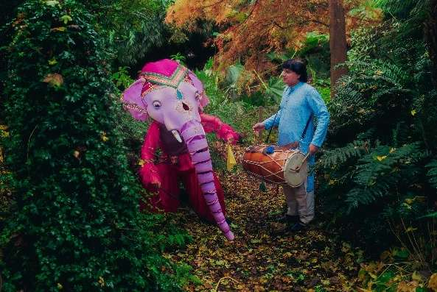 | The Elephant And The Drummer  Join Elnaz the Elephant and Dholli the Drummer for a fun adventure in Greenwich Park, with amazing puppets and live music.  Date: Saturday 23rd & Sunday 24th August  Time: 1:30pm, 3:45pm, and 5:25pm (30mins)  Location: General Wolfe Piazza  For full access information:  https://festival.org/gdif/whats-on/the-elephant-and-the-drummer/
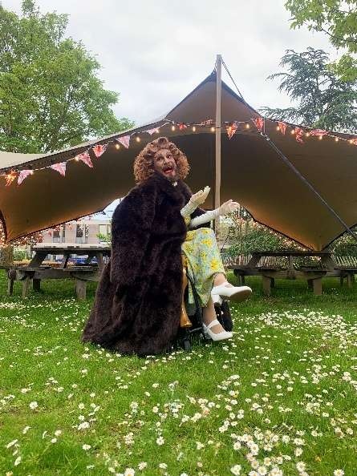 | It's Classic Connee  A big, fun, lip-sync show celebrating Connee Boswell.  Date: Saturday 23rd & Sunday 24th August  Time: 1:35pm and 3:40pm (30mins)  Location: General Wolfe Piazza  For full access information:  https://festival.org/gdif/whats-on/its-classic-connee/
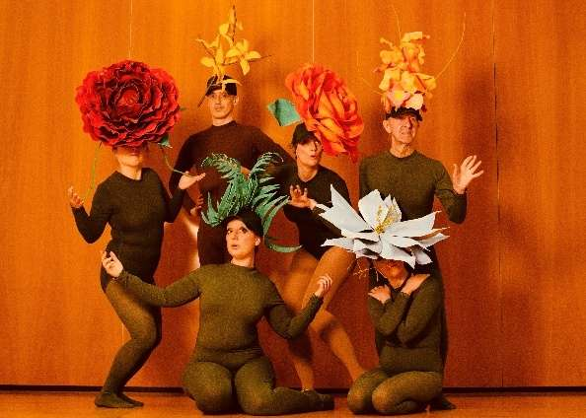 | Lady Garden  Explore the fun, world of flowers in this mix of performance, dance and comedy.  Date: Saturday 23rd August  Time: 2:05pm and 4:20pm (30mins)  Location: Hedgerow  For full access information:  https://festival.org/gdif/whats-on/lady-garden/
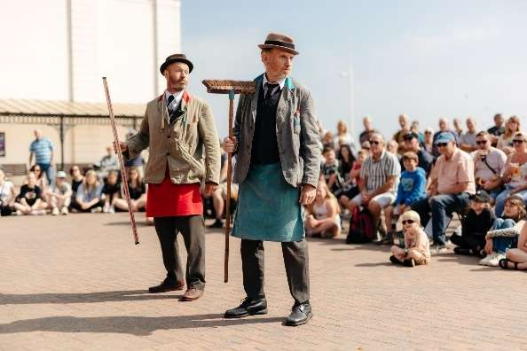 | Tony & Ray Find Their Feet  Tony and Ray’s fun show celebrates friendship, silly jokes, dance and bringing joy to audiences of all ages.  Date: Saturday 23rd & Sunday 24th August  Time: 2:50pm and 5:25pm (15mins)  Location: The Avenue  For full access information:  https://festival.org/gdif/whats-on/tony-ray-find-their-feet/
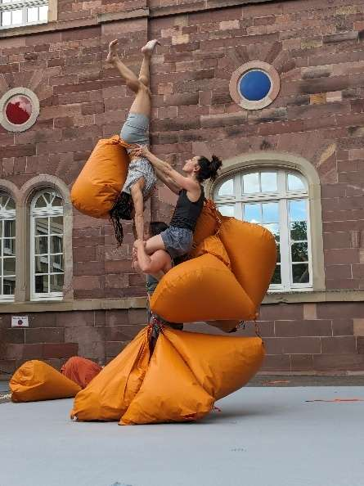 | Weight(Less)  A blend of acrobatics, movement and humour.  Date: Saturday 23rd & Sunday 24th August  Time: 1pm and 4:15pm (30mins)  Location: General Wolfe Piazza  For full access information:  https://festival.org/gdif/whats-on/weight-less/
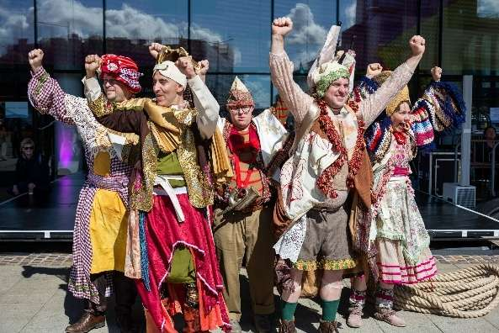 | TRUTH!  A playful call to action and quiet rebellion with games, theatre, dance and participation.  Date: Sunday 24th August  Time: 4:05pm and 4:20pm (45mins)  Location: Hedgerow  For full access information:  https://festival.org/gdif/whats-on/truth/
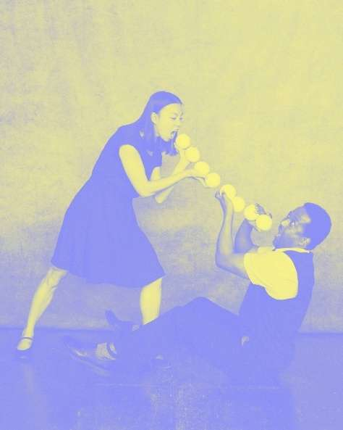 | You Too Can Tutu  A mix up of classical ballet and juggling tricks.  Date: Saturday 23rd & Sunday 24th August  Time: 1pm and 3:10pm (20mins)  Location: Hedgerow  For full access information:  https://festival.org/gdif/whats-on/you-too-can-tutu/
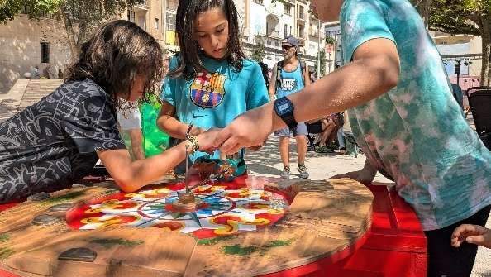 | Arrels  20 large interactive games from different places around the world  Date: Saturday 23rd & Sunday 24th August  Time: all day  Location: General Wolfe Piazza  For full access information:  https://festival.org/gdif/whats-on/arrels/
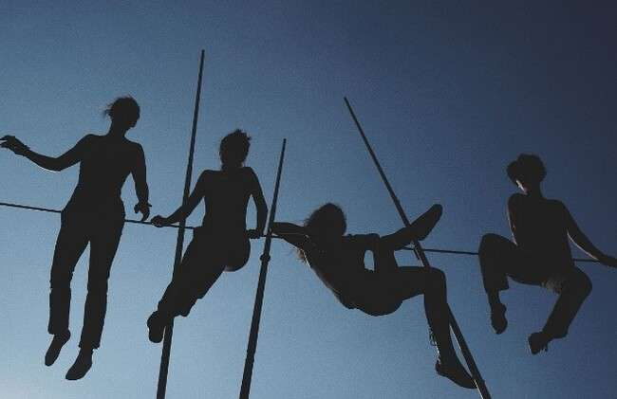 | Epiphytes  Four high-wire performers evoke the imagery of trees growing  Date: Saturday 23rd & Sunday 24th August  Time: 1pm to 6pm (45mins)  Location: Lawn Lookout, Observatory Hill  For full access information:  https://festival.org/gdif/whats-on/epiphytes/

Access

 | GDIF welcomes all and aims to be accessible to everyone.
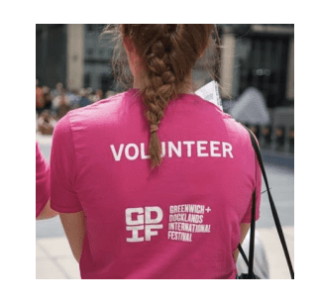 | Our friendly staff and volunteers are there to help.  They will be wearing pink t-shirts.
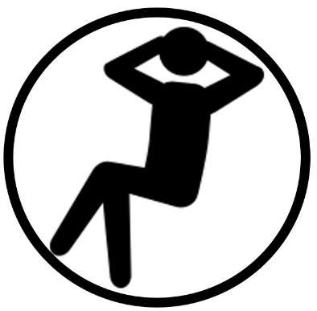 | All shows and sites are relaxed.  You are welcome to:  ・Move around – just not on stage.  ・Make noise  ・Join and leave at any time  We have a low sensory area on site. This is somewhere away from noise and crowds.
       | Access on site:  All shows are wheelchair accessible.  We welcome Assistance Dogs.  Viewing areas with chairs will be available.  Accessible toilet and blue badge parking information is available on our website.
     | Accessible shows:  Most events with speech will provide BSL interpretation.  Many shows will have Audio Description and touch tours.  Easy Read is available via QR codes, and there will be printed copies at our Access Areas.
     | For more information  Contact: Evie Ayres-Townshend  Website: https://festival.org/gdif/access/  E-mail: access@festival.org  Phone: 07899 893 935

Support GDIF

 | We would be grateful if you would consider donating to GDIF.
You can do this by visiting:

bit.ly/supportGDIF

Photography and filming

 | We have photographers and film makers at events to capture footage to share online and for use in future.  If you don’t want to have your photo taken, please wear a ‘No Photography’ sticker, available from our volunteers.  Got some great photos you want to share? Tag us @GDIFestival and use #GDIF2025.


