Greenwich Fair - Observatory Hill Greenwich
Route from Blackheath Gate Entrance and St Mary’s Gate
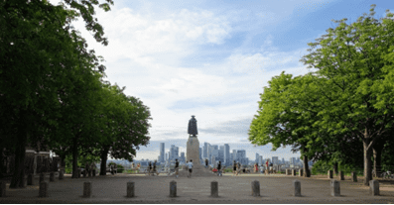 | Address:  General Wolfe Piazza, Observatory Hill, Greenwich Park, SE10 8XJ  What 3 Words:  ///voice.light.belts
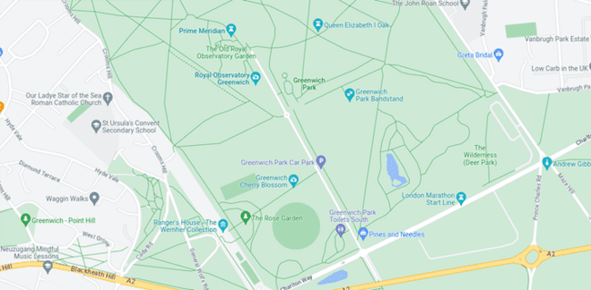
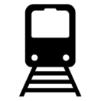 | Transport  Trains to Greenwich Station  Blackheath Gate:  Busses 53, 453  St Mary’s Gate;  Busses 129, 177, 188, 286, 386, N1
 | Plan Your Journey:  Visit www.tfl.gov.uk to plan your journey.

Route from Blackheath Gate Entrance
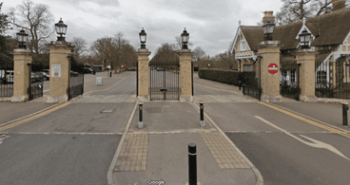 | Head through the gates, onto Blackheath Avenue
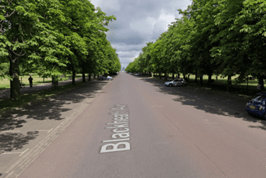 | Continue down Blackheath Avenue
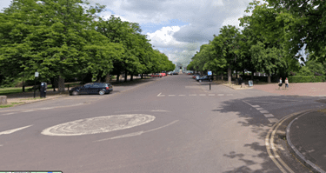 | At the roundabout, head straight on
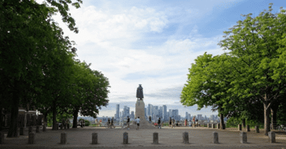 | You will reach General Wolfe Piazza.  Volunteers will be there to welcome you and direct you to different shows

Route from St Mary's Gate
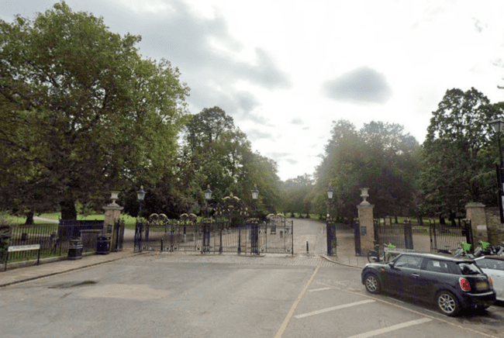 | Head through the gates, onto Blackheath Avenue
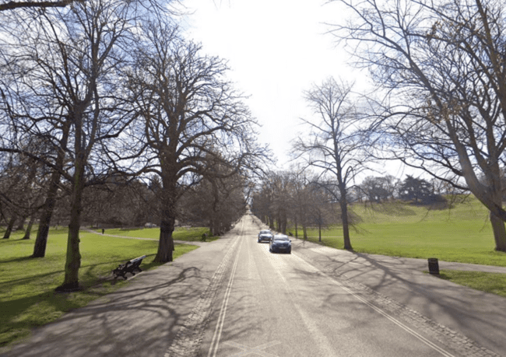 | Continue up the straight road
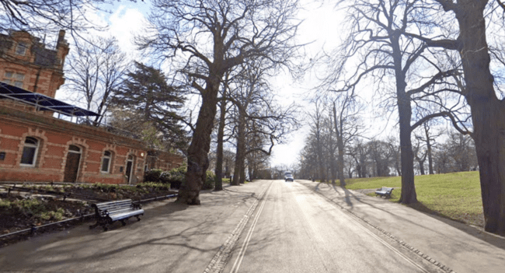 | Continue up the hill until you pass public toilets on your left
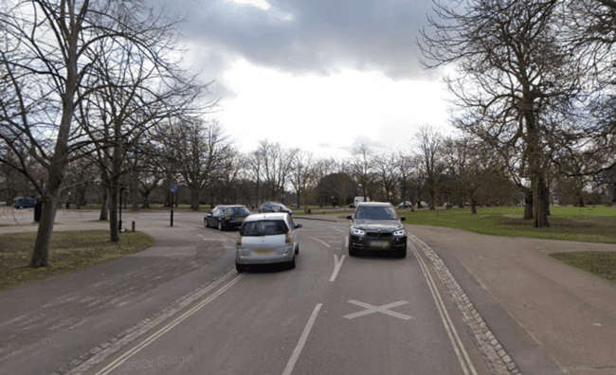 | Follow the road round to the left to the mini roundabout.
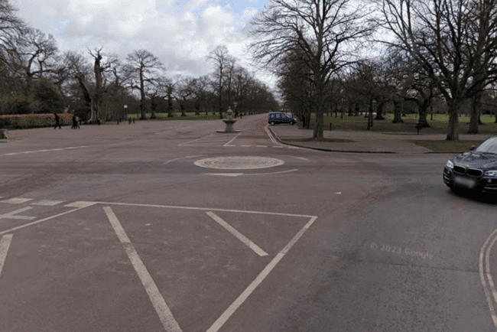 | You will reach the Festival site  Volunteers will be there to welcome you and direct you to different shows

