One Sky, Dancing City- Stratford Walk
Route from Stratford Station
 | Address:  Stratford Walk, E20 1EJ  What 3 Words:  https://w3w.co/that.status.fame
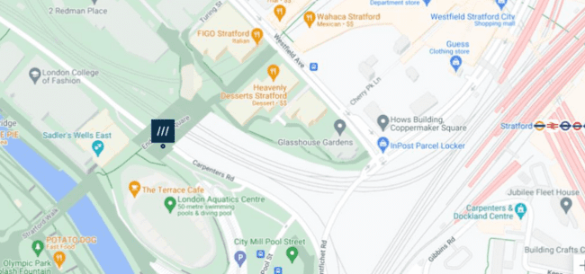
 | Transport  Stratford Station and Bus Station
 | Plan Your Journey:  Visit www.tfl.gov.uk

Route from Stratford Station, Montfichet Road (Westfield Exit)

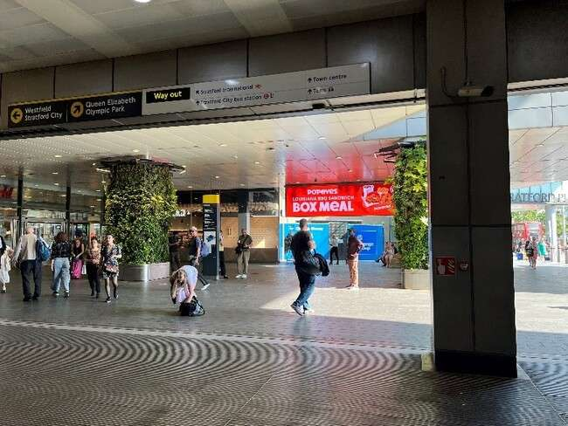 | Exit Stratford Station onto Montfichet Road (Westfield Exit)
 | Use the lift, stairs or escalators opposite the station exit to get to level 1.

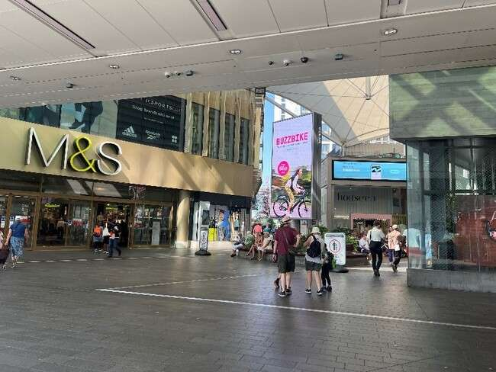 | Turn into Westfield shopping center and walk past M&S on your left.
 | Continue down the covered avenue of shops.
 | Exit the covered area and turn left past the restaurants and covered seating.
 | Cross Westfield Avenue and continue straight on.
 | Continue straight through  Stratford Cross.
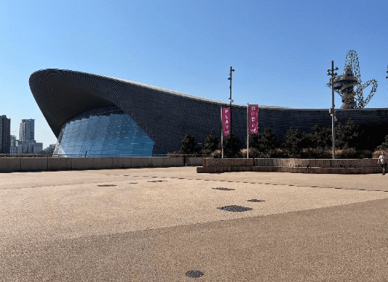 | One Sky will be outside the  Aquatics Centre on your left on Stratford Walk, opposite Sadler’s Wells East.

