Passage, Dancing City- Fountain Square
Route from Stratford Station
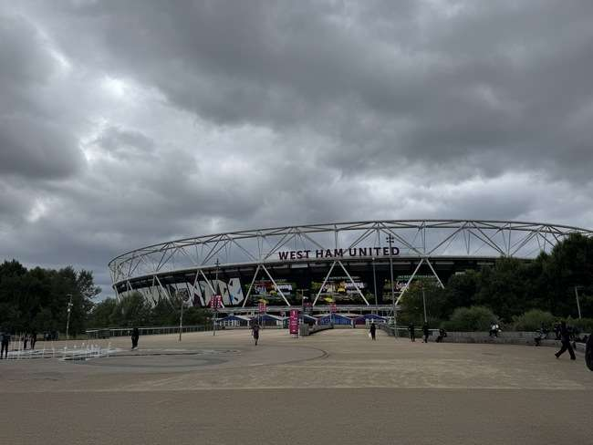 | Address:  Queen Elizabeth Olympic Park, London, E20 2ST  What 3 Words:  https://w3w.co/rail.entry.slide
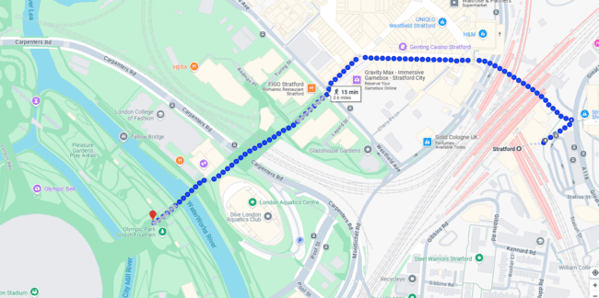

 | Transport  Stratford Station and Bus Station
 | Plan Your Journey:  Visit www.tfl.gov.uk

from Stratford Station, Montfichet Road (Westfield Exit)
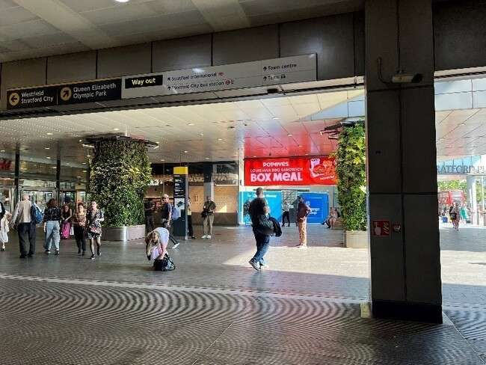 | Exit Stratford Station onto Montfichet Road (Westfield Exit)
 | Use the lift, stairs or escalators opposite the station exit to get to level 1.

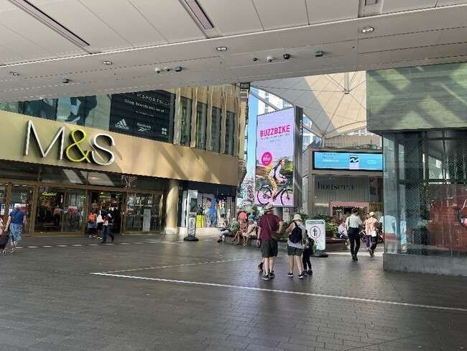 | Turn into Westfield shopping center and walk past M&S on your left.
 | Continue down the covered avenue of shops.
 | Exit the covered area and turn left past the restaurants and covered seating.
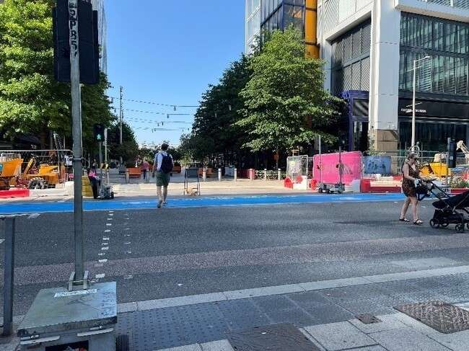 | Cross Westfield Avenue and continue straight on.
 | Continue straight through Stratford Cross on Stratford Walk.
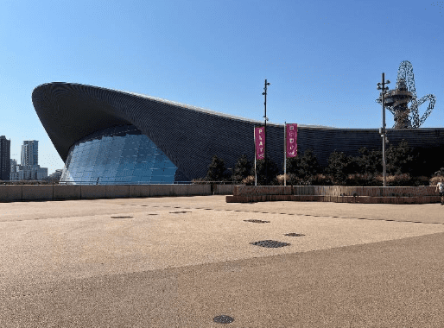 | Pass the Aquatics Centre on your  left on Stratford Walk.
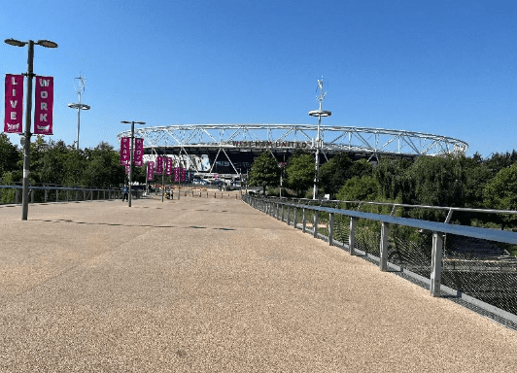 | Cross the bridge towards the Stadium.
 | Passage will take place in the open space across the bridge.

