Passionately Defiant.
JPM Productions.

Visual Guide

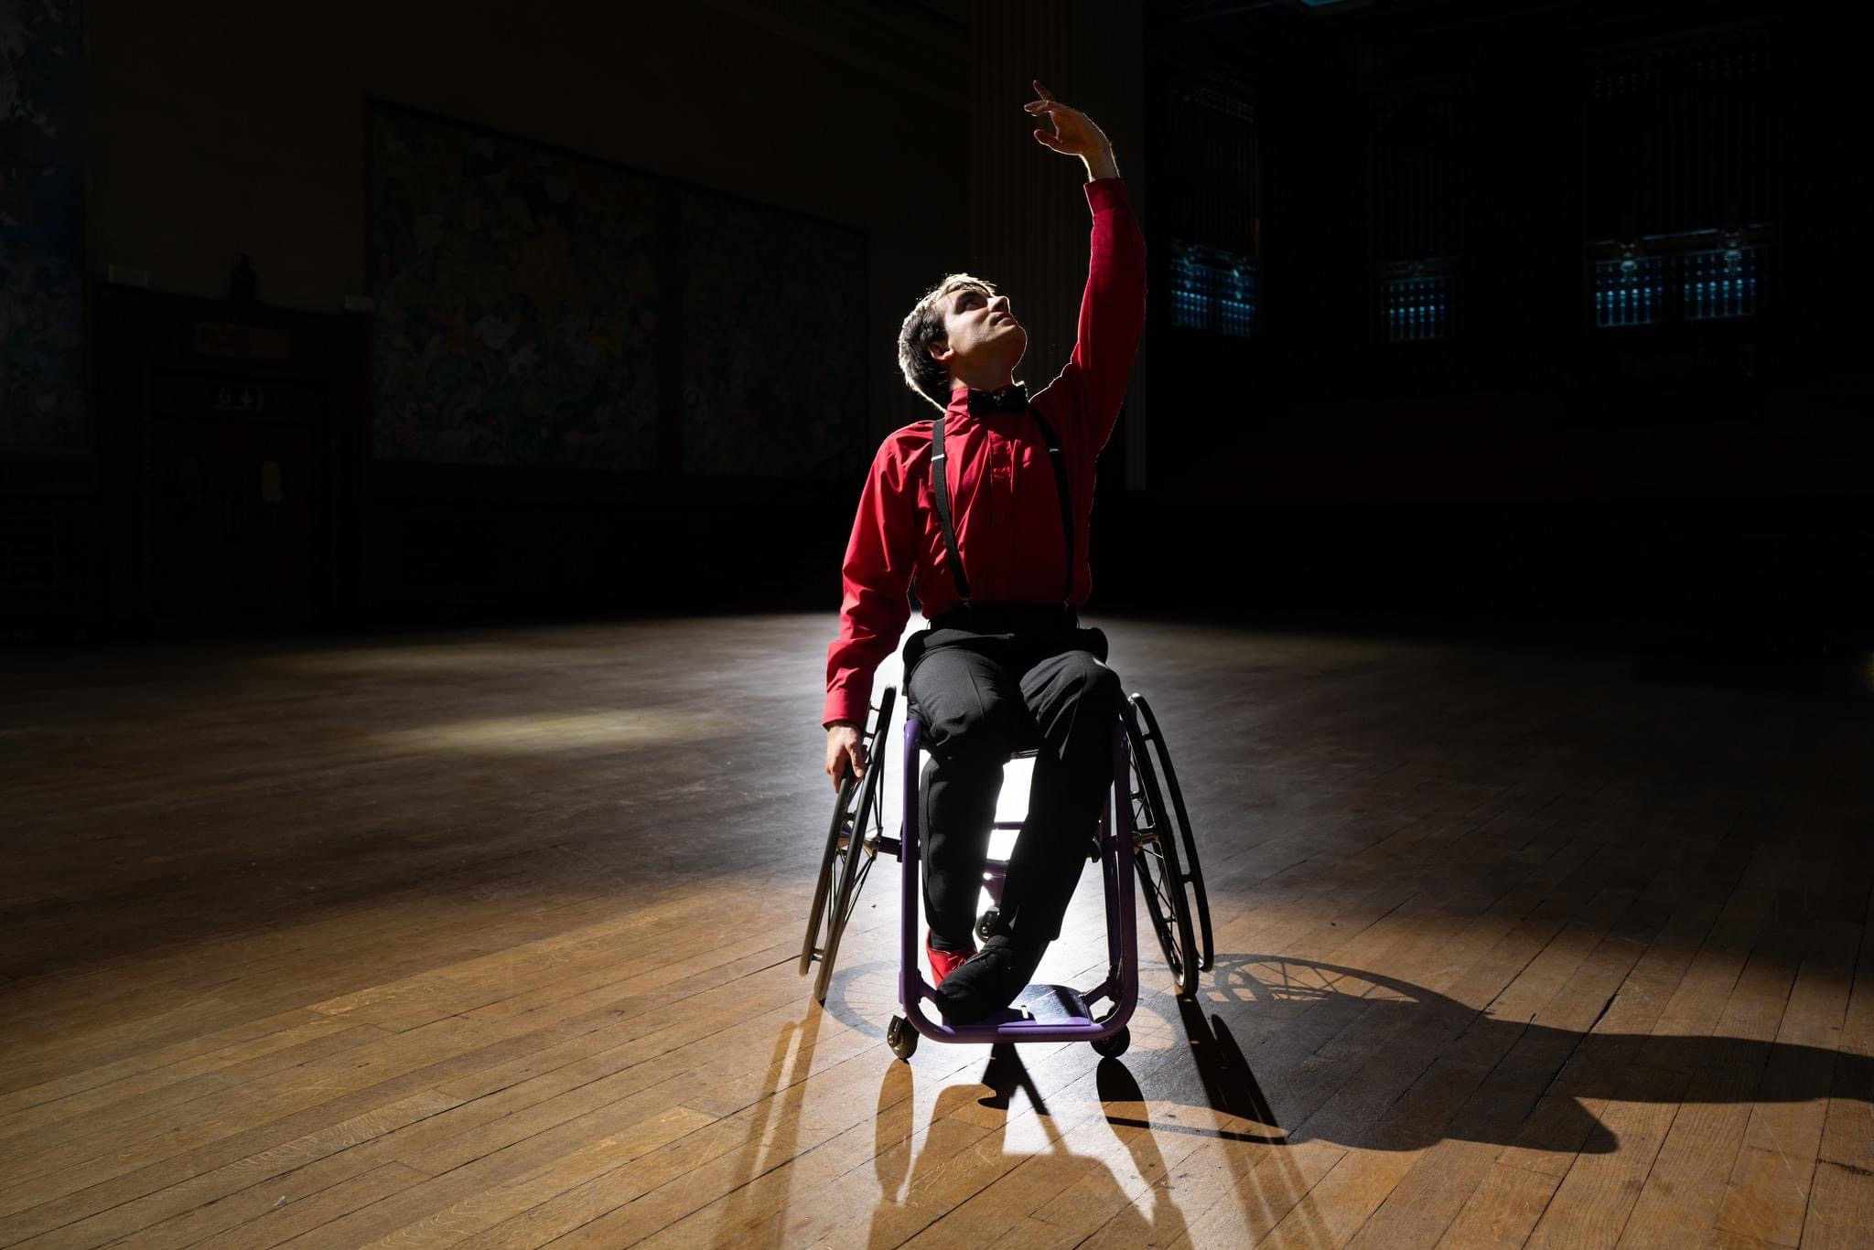

A dancer in wheelchair wearing a bright red shirt raises his hand and arm above his head.

What to Expect

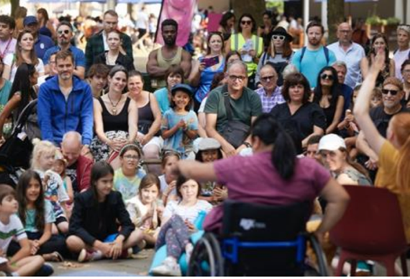 | Who is it for?  This show is suitable for audiences of all ages.
 | Dates and Times:  6th September  1:55pm and 3:30pm
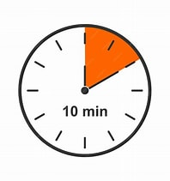 | Length of show:  Approximately 10 mins.
   | Access:  - Speech Free  - Live AD 3:30pm  - Easy Read Information
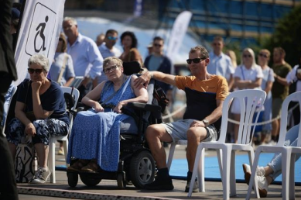 | Access Viewing Area for:  - Wheelchair users.  - Anyone who needs a seat.  - Companions.  - Anyone who needs it for access reasons.
 | Music and Sound:  The music is recorded. There may be points of loud and dramatic crescendo.
 | Content  Themes of dramatic intention and joy of movement. There are points of risk, but please don’t worry the performer has been trained to do this in a safe manner.
 | You are welcome:  ・Move around – just not on stage.  ・Make noise  ・Join and leave at any time
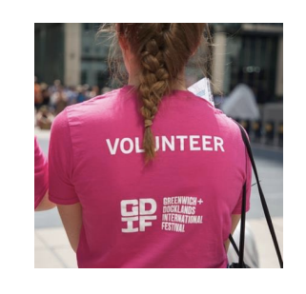 | Volunteers:  Friendly volunteers are there to help.  They will be wearing pink t-shirts.

About Passionately Defiant
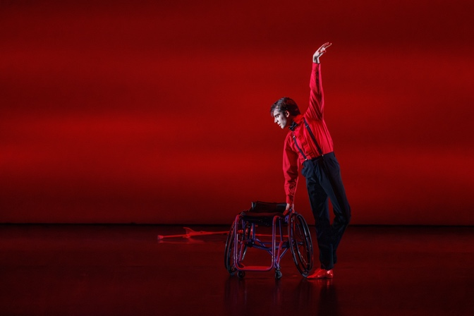 | A joyous and hopeful celebration of dance and disability pride.  A mix of paso doble, tango and classical ballet techniques.  A performance telling the story of Joe’s journey back to dance after becoming disabled at the age of 15.  He then became the first wheelchair user to dance with the Royal Ballet.

What happens in the show

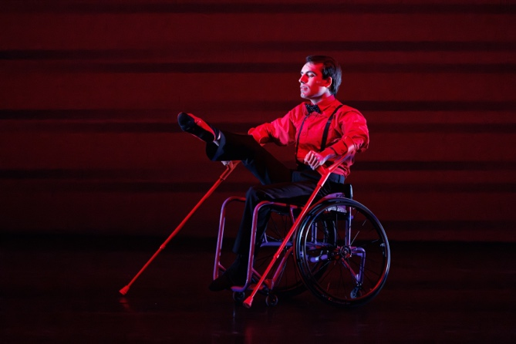 | The performer enters the space in a dramatic way using his red crutches to propel his wheelchair.
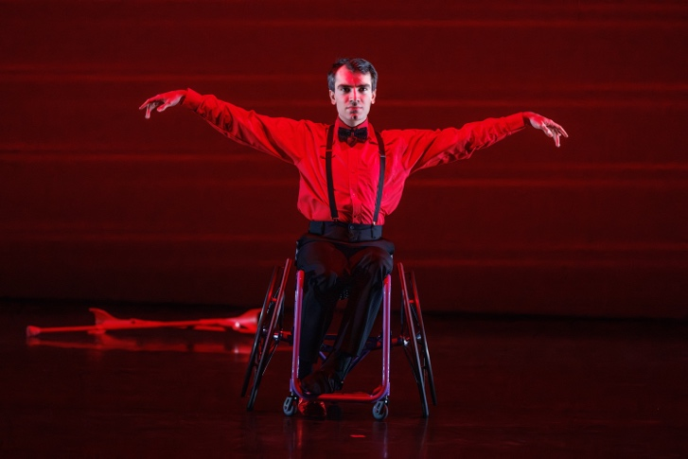 | Downstage and close to the audience the dancer with a strong look throws his arms dramatically out to the side.
 | The soloist stands on one foot with his arm stretched about him using the wheelchair to support his weight.
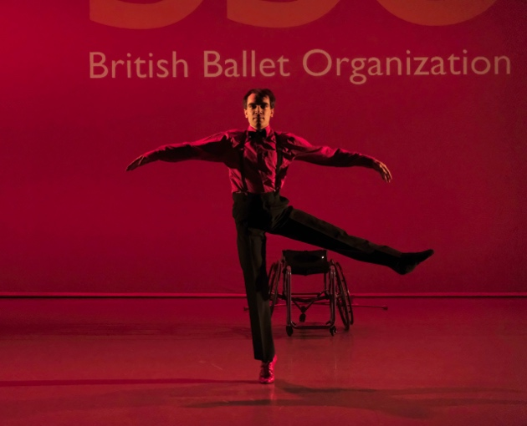 | The dancer uses his functioning leg to balance in a series of turns

Creative team

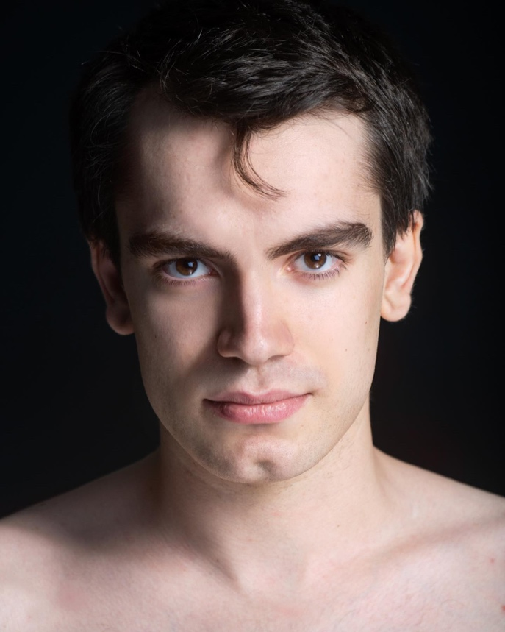 | Joe Powell-Main  Choreographer, Director and Performer.

Find out more

 | Info about the company:  E.g. Bandaloop are one of the world’s most extraordinary vertical dance companies. They experiment with climbing technology to re-imagine dance.  https://www.bandaloop.org/
 | Contact  Evie Ayres-Townshend (Access Producer)  Email: access@festival.org  Call or text: 07899 893 935

