Roots to Rise, 360 Dancing City- Carousel
Route from Stratford Station
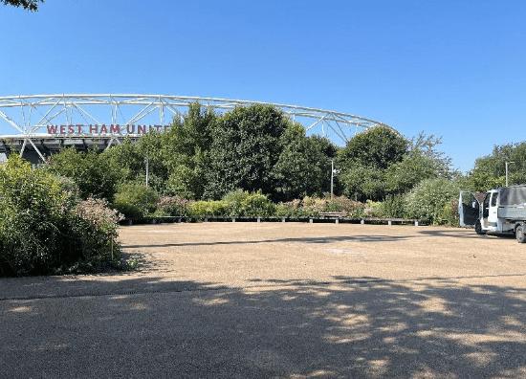 | Address:  Queen Elizabeth Olympic Park  The Carousel, E20 2ST  What 3 Words:  //what3words.com/bets.full.tops
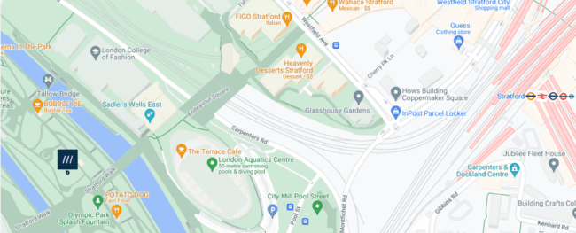
 | Transport  Stratford Station and Bus Station
 | Plan Your Journey:  Visit www.tfl.gov.uk
Route from Stratford Station, Montfichet Road (Westfield Exit)
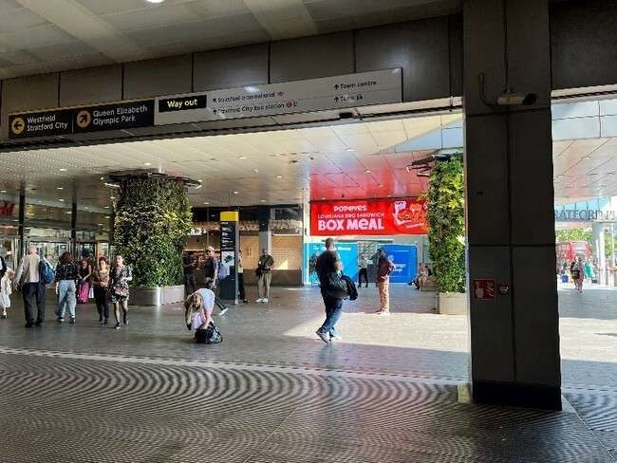 | Exit Stratford Station onto Montfichet Road (Westfield Exit)
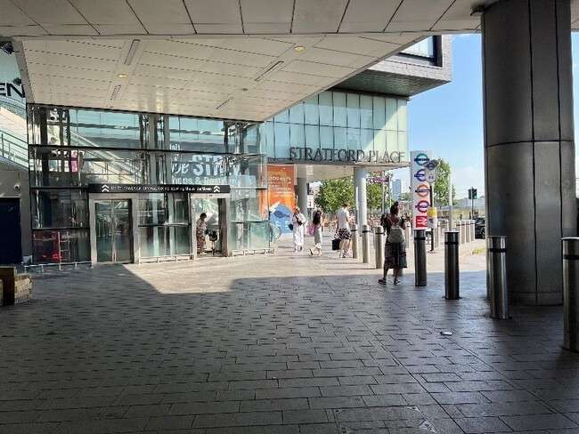 | Use the lift, stairs, or escalators opposite the station exit to get to level 1.
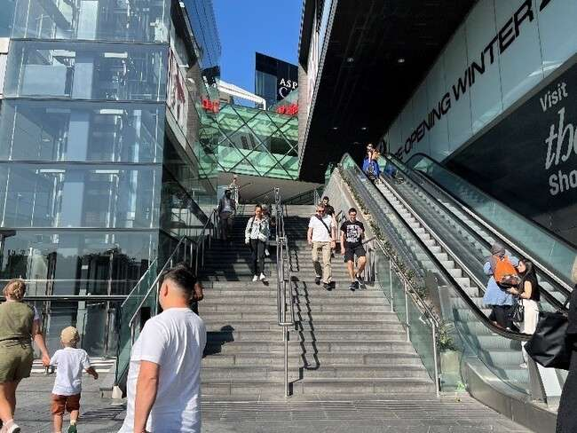
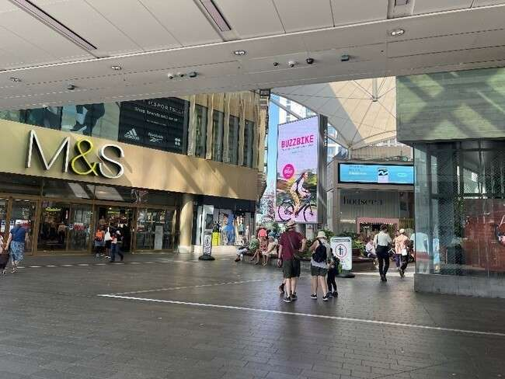 | Turn into Westfield shopping center and walk past M&S on your left.
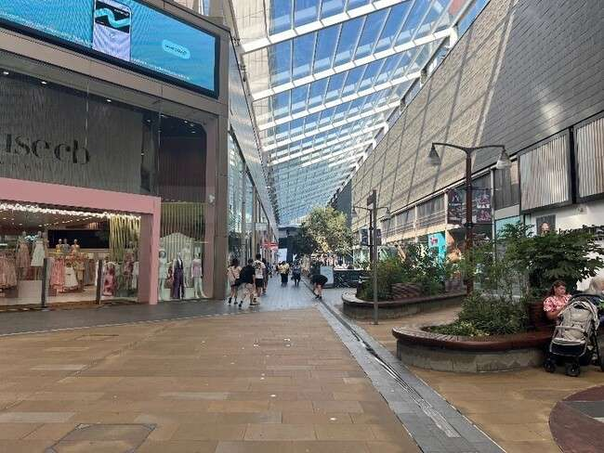 | Continue down the covered avenue of shops.
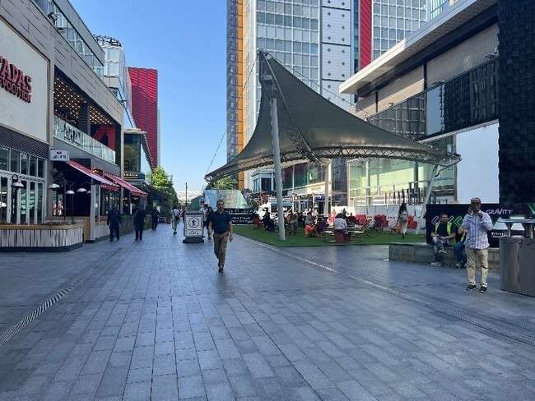 | Exit the covered area and turn left past the restaurants and covered seating.
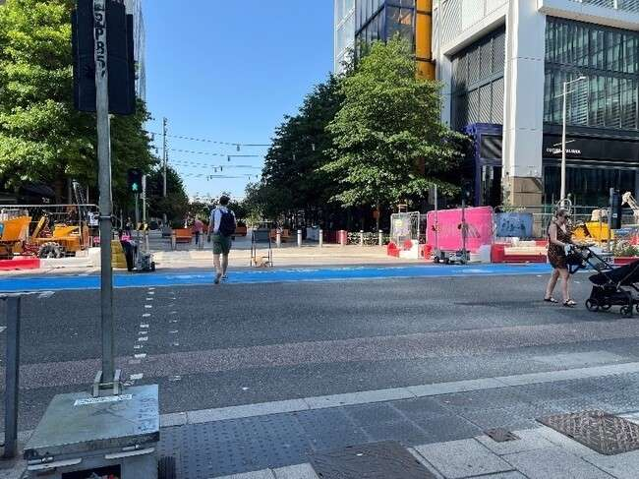 | Cross Westfield Avenue and continue straight on.
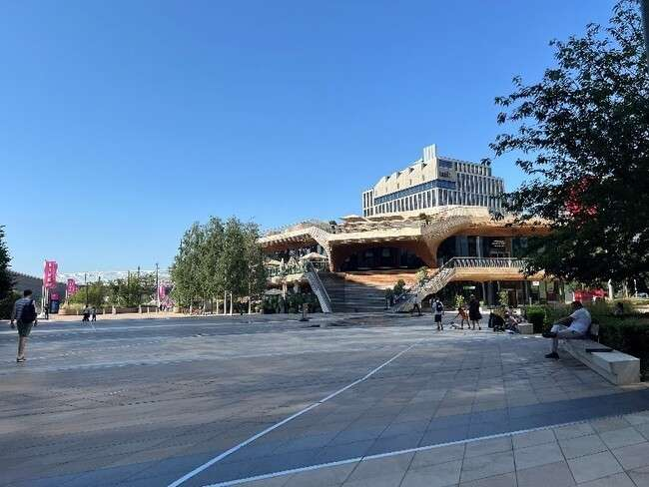 | Continue straight through  Stratford Cross on Stratford Walk.
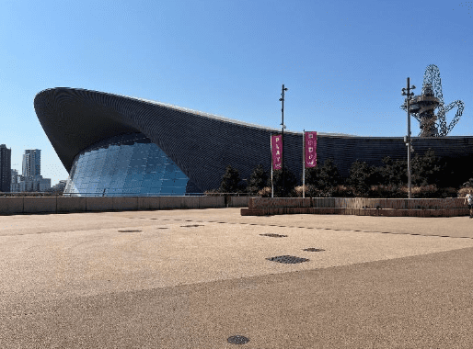 | Pass the Aquatics Centre on your  left on Stratford Walk.
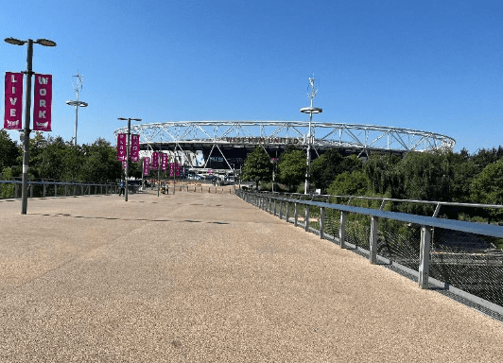 | Cross the bridge towards the  stadium
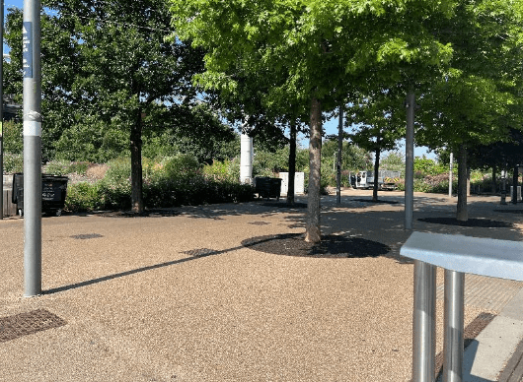 | After the bridge turn right onto the  path with trees.
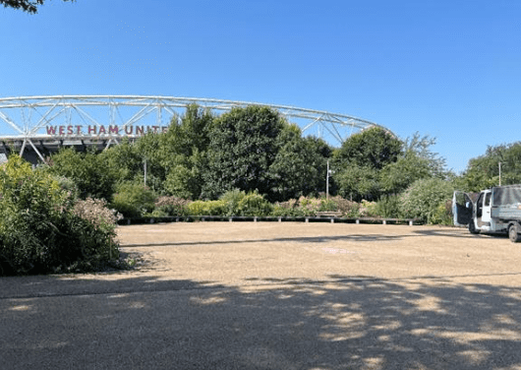 | At the ice cream truck look left and you will see the performance site.

