Through Another Lens by Restless Dance Theatre

Visual Guide

Show image – Dancer Jianna Georgiou. Photo by Shane Reid

[A fresh dance perspective on movement, identity and possibility]

What to Expect (Add boxed if needed)

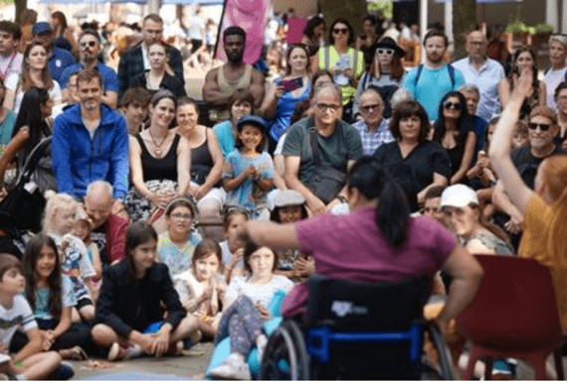 | Who is it for?  This show for suitable for all ages.
 | Dates and Times:  6 September 2025  2:55pm, 5pm
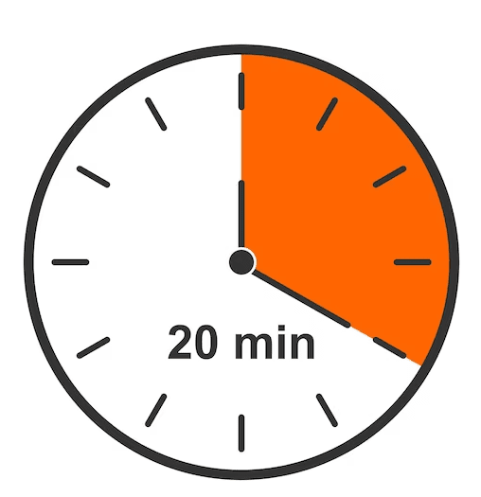 | Length of show:  17 mins
   | Access:  No Spoken Dialogue
 | Access Viewing Area for:  - Wheelchair users.  - Anyone who needs a seat.  - Companions.  - Anyone who needs it for access reasons.
 | Music and Sound:  The music Is played through a sound system.
 | You are welcome:  ・Move around – just not on stage.  ・Make noise  ・Join and leave at any time
 | Volunteers:  Friendly volunteers are there to help.  They will be wearing pink t-shirts.

About Through Another Lens

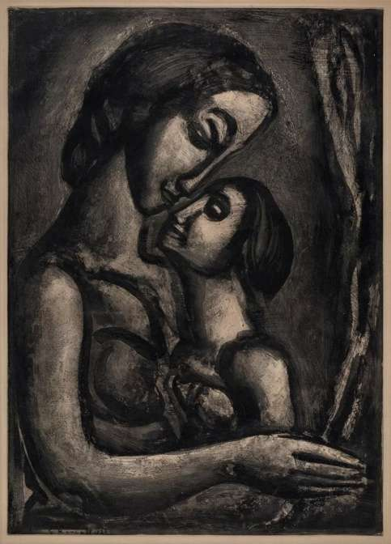 | Inspired by the work French expressionist, Georges Rouault.
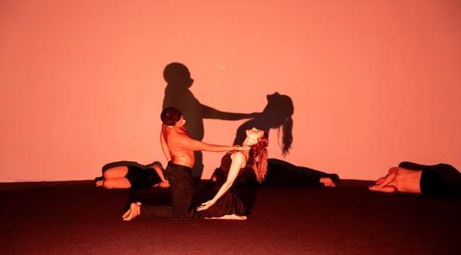 | Exploring universal themes of friendship
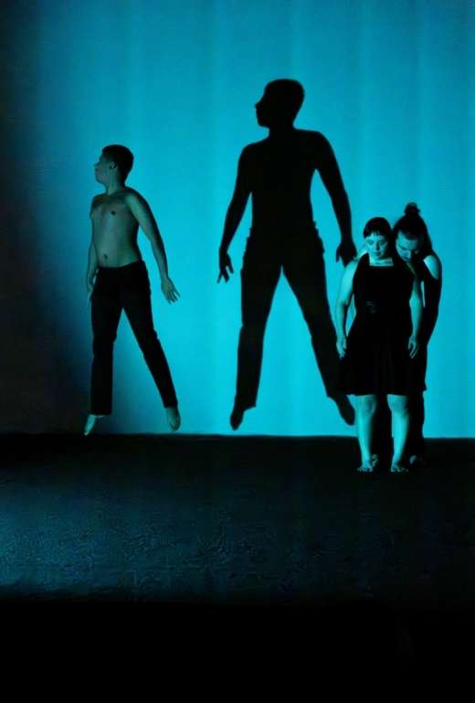 | Strength and connection
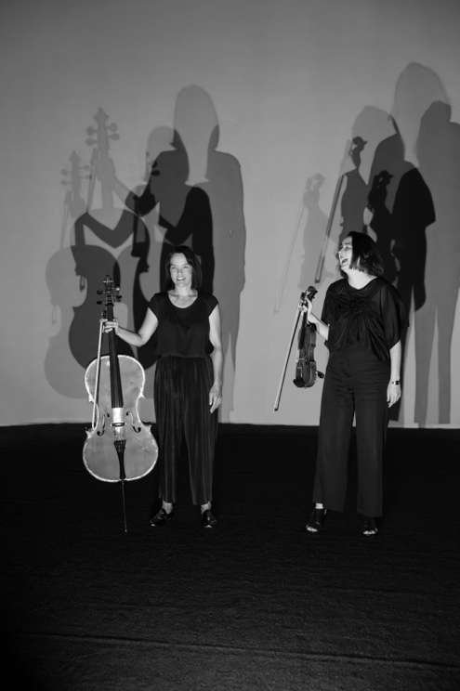 | An emotive original score for violin and cello.
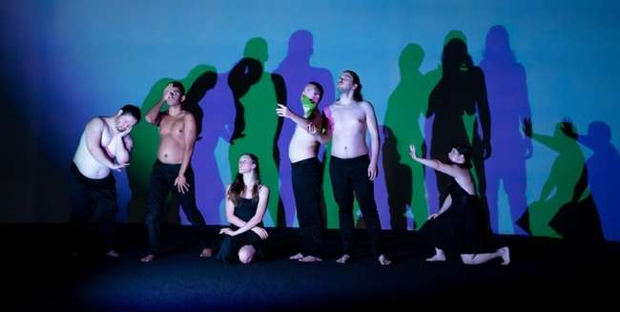 | Diverse minds and bodies

What happens in the show

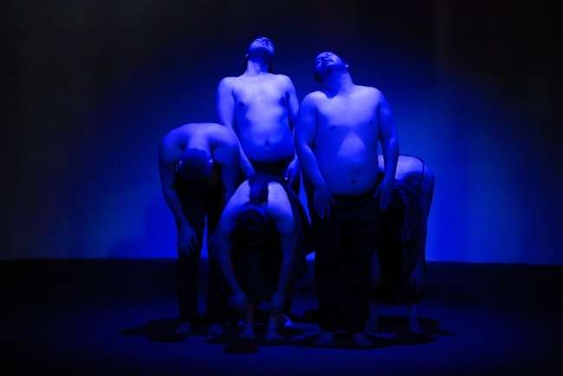 | Dancers start on the ground and slowly stand, moving as a group
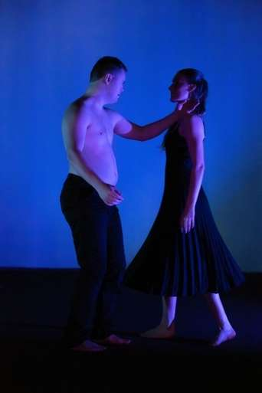 | A duet between a male and female dancer
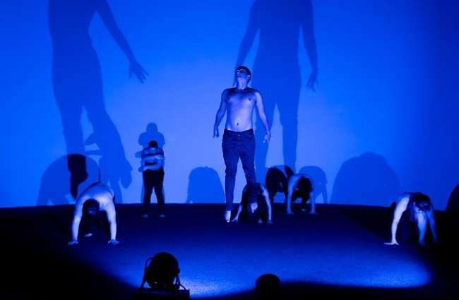 | A male dancer jumps in time with the music
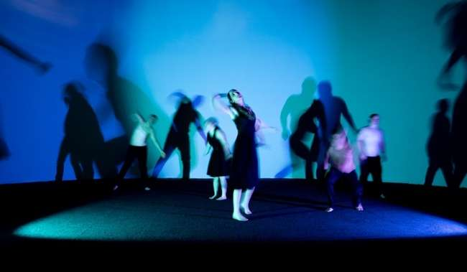 | All dancers move individually then in unison
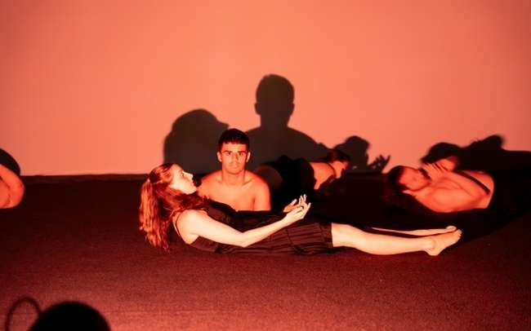 | A duet between a different female and male dancer
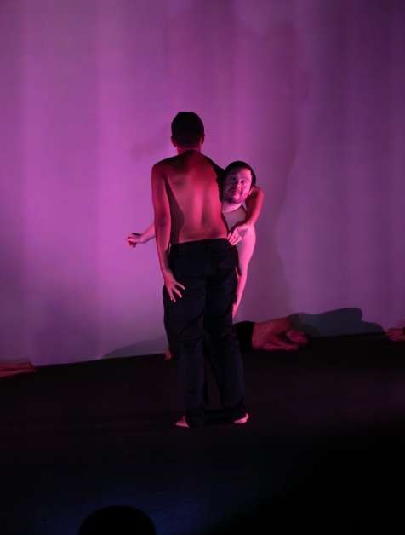 | A duet between two male dancers
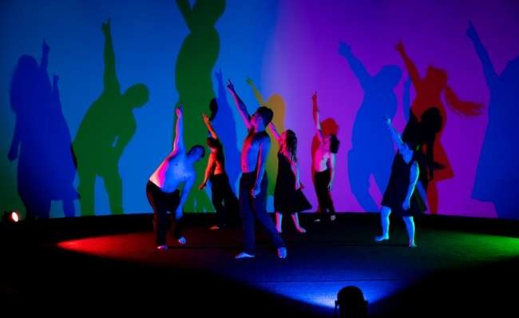 | All dancers join in unison
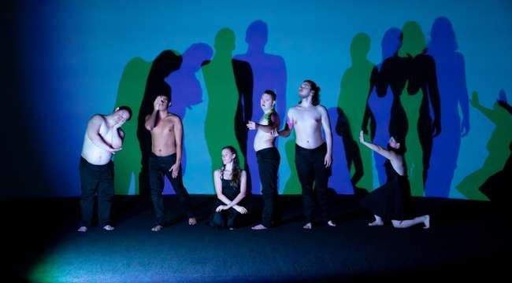 | A series of portraits are performed
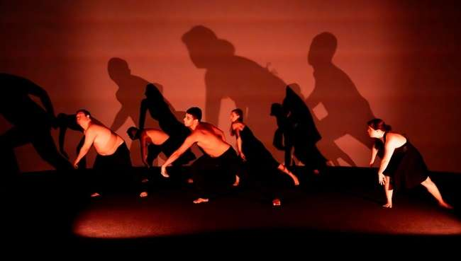 | In the final section, the dancers move more freely in unison

Creative team

 | Michelle Ryan,  Director
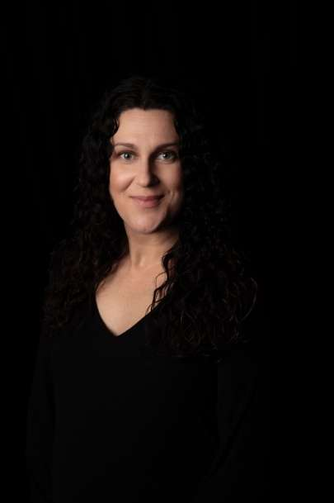 | Larissa McGowan,  Assistant Director
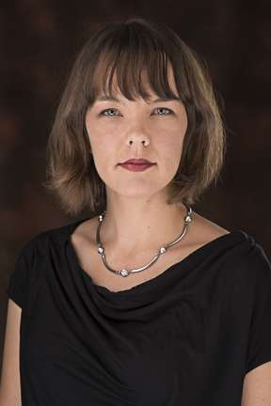 | Composers,  Hilary Kleinig & Emily Tulloch

Find out more

 | Info about the company:  Restless Dance Theatre is Australia’s leading creator of dance theatre by dancers with and without disability. Our artistic voice is loud, strong and original. Restless brings artists with diverse minds, bodies and imaginations together to create contemporary dance theatre from everyday lived experience; manifested into beautiful art, embedding inclusion into our screens, on our stages and in unexpected places. Led by artist with disability Michelle Ryan and CEO Julie Moralee, Restless Dance Theatre is a place where diversity is celebrated, and all artists thrive creatively.  https://restlessdance.org
 | Contact:  Evie Ayres-Townshend (Access Producer)  Email: access@festival.org  Call: 07899 893 935

