Through Another Lens, Dancing City- Waterfront Square
Route from Stratford Station
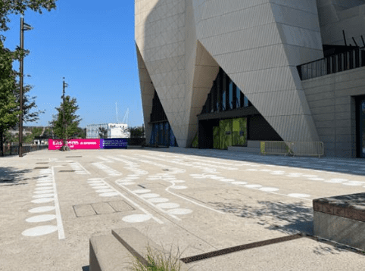 | Address:  Queen Elizabeth Olympic Park  Waterfront Square, E20 2AQ  What 3 Words:  https://w3w.co/cross.orbit.pets
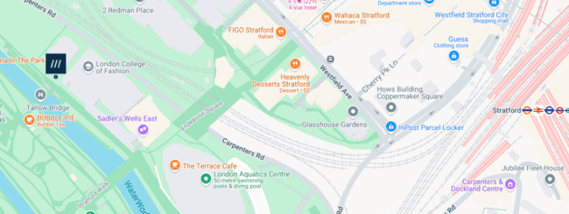
 | Transport  Stratford Station and Bus Station
 | Plan Your Journey:  Visit www.tfl.gov.uk
Route from Stratford Station, Montfichet Road (Westfield Exit)
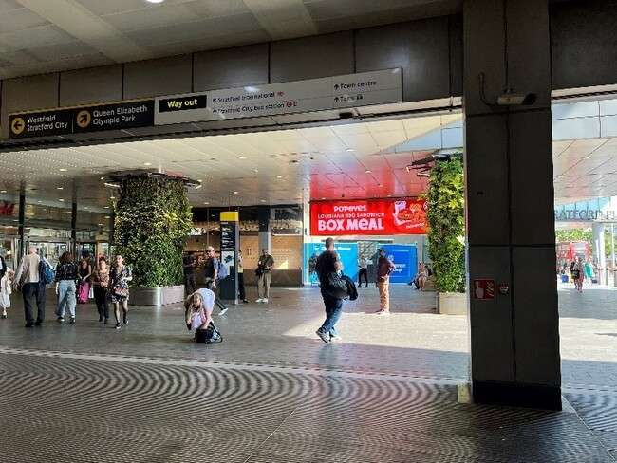 | Exit Stratford Station onto Montfichet Road (Westfield Exit)
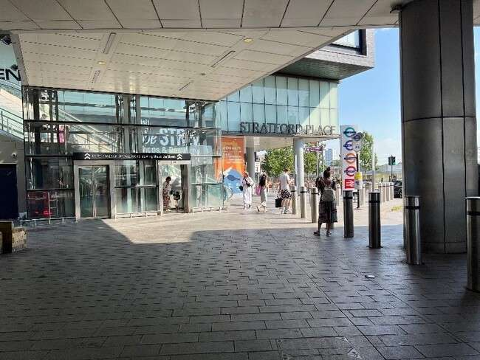 | Use the lift, stairs or escalators opposite the station exit to get to level 1.
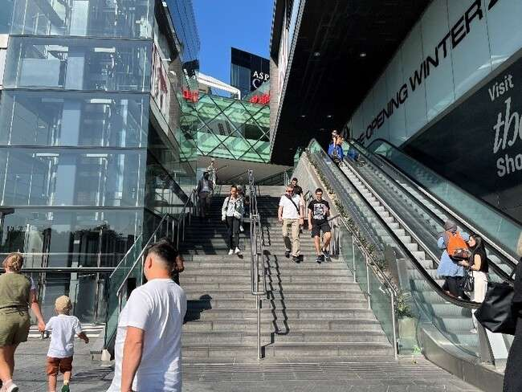
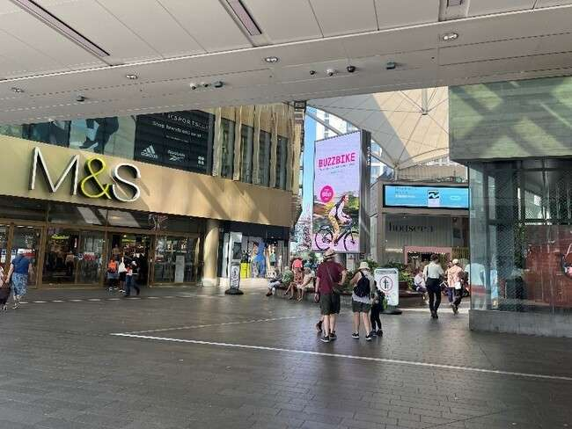 | Turn into Westfield shopping center and walk past M&S on your left.
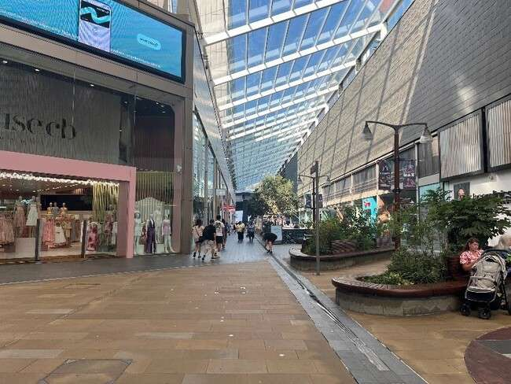 | Continue down the covered avenue of shops.
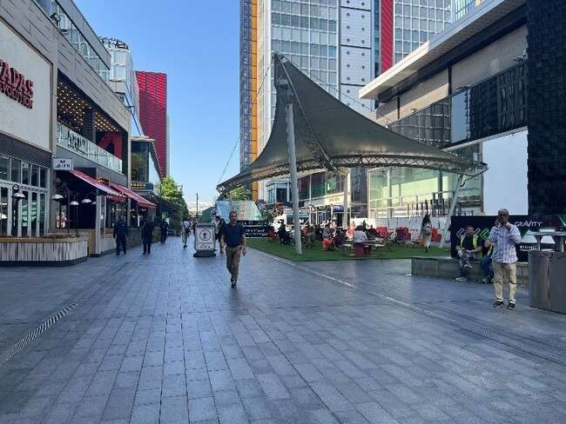 | Exit the covered area and turn left past the restaurants and covered seating.
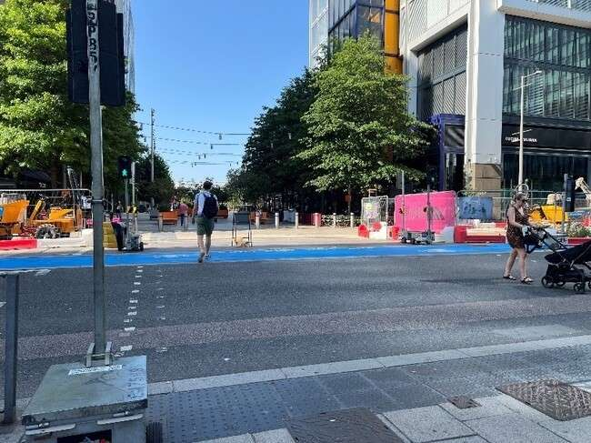 | Cross Westfield Avenue and continue straight on.
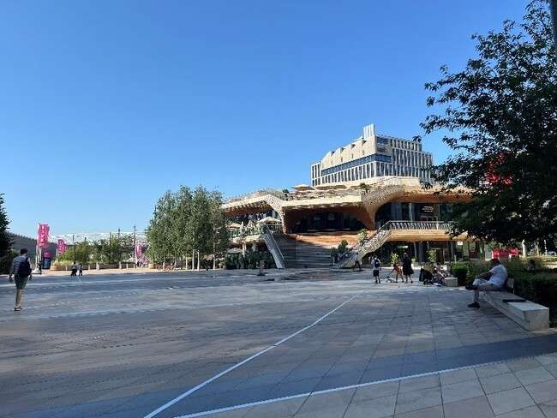 | Continue straight through  Stratford Cross on Stratford Walk.
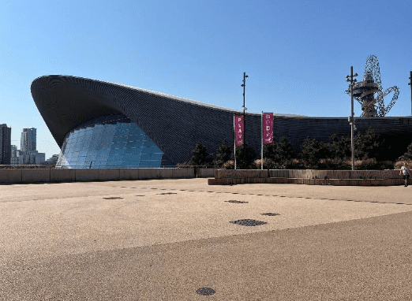 | Pass the Aquatics Centre on your  left on Stratford Walk.
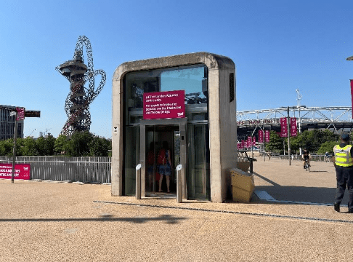 | Before the bridge take the lift  down to the riverside.
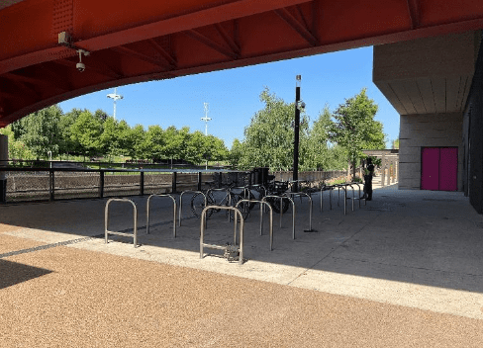 | Go under the bridge and past the  bike storage.
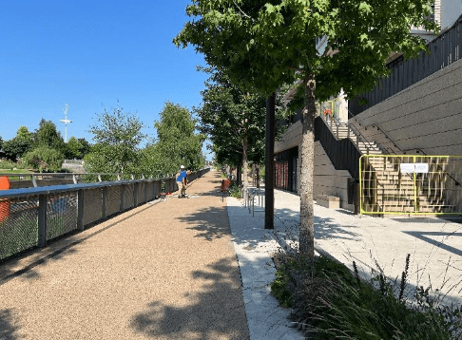 | Continue along the riverside path  with the river on your left for 100m approx.
 | You will reach the site for Through Another Lens.

