WaterKind, Dancing City- Carpenters Lock
Route from Stratford Station
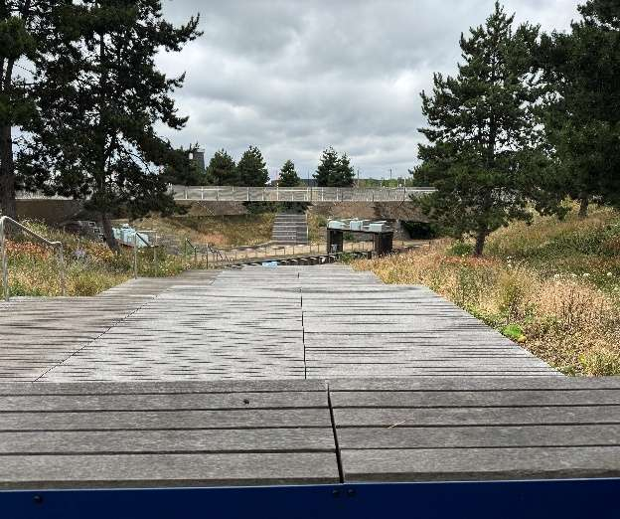 | Address:  Carpenter’s Lock, Queen Elizabeth Olympic Park, London, E20 2ST  What 3 Words：  https://w3w.co/sits.jabs.lows
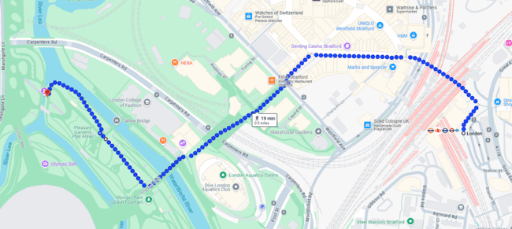

 | Transport  Stratford Station and Bus Station
 | Plan Your Journey:  Visit www.tfl.gov.uk

Route from Stratford Station, Montfichet Road (Westfield Exit)
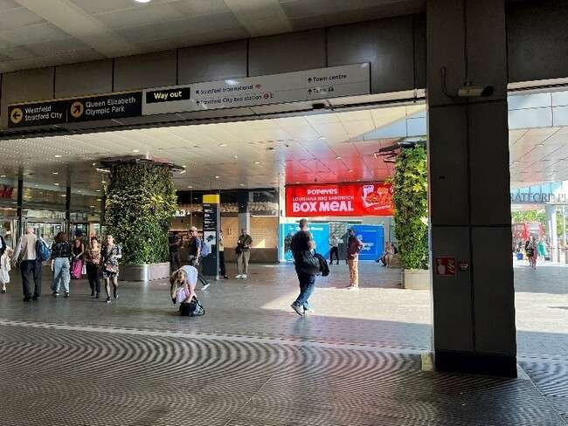 | Exit Stratford Station onto Montfichet Road (Westfield Exit)
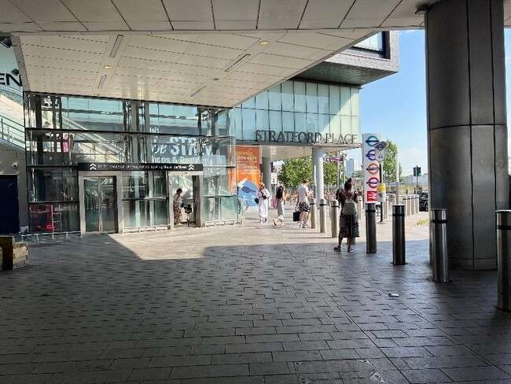 | Use the lift, stairs or escalators opposite the station exit to get to level 1.
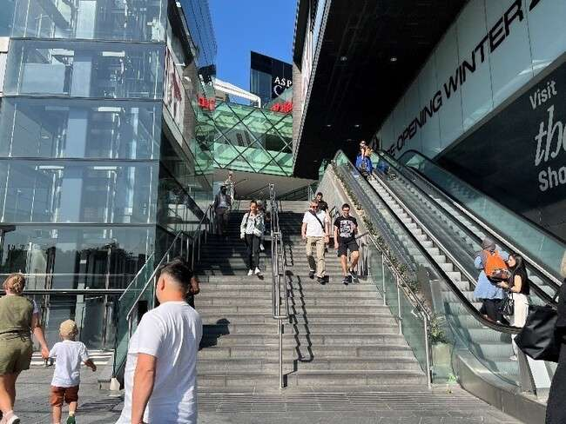
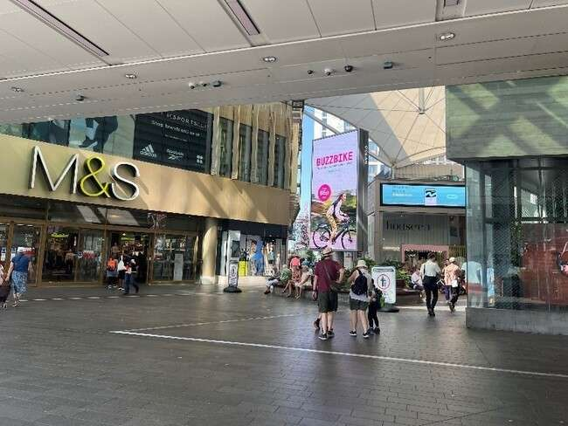 | Turn into Westfield shopping center and walk past M&S on your left.
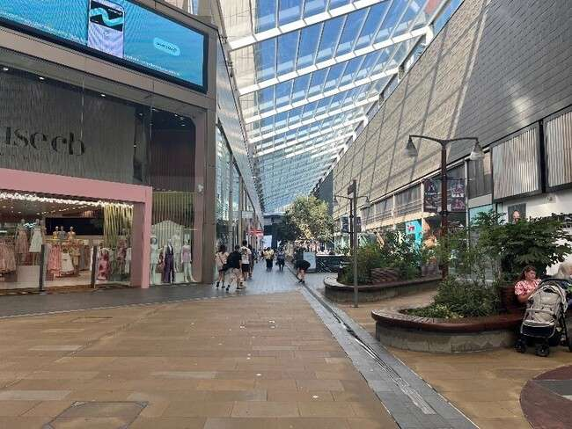 | Continue down the covered avenue of shops.
 | Exit the covered area and turn left past the restaurants and covered seating.
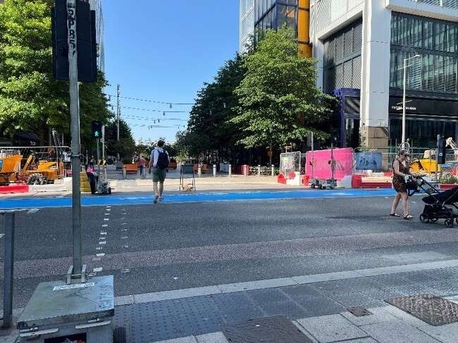 | Cross Westfield Avenue and continue straight on.
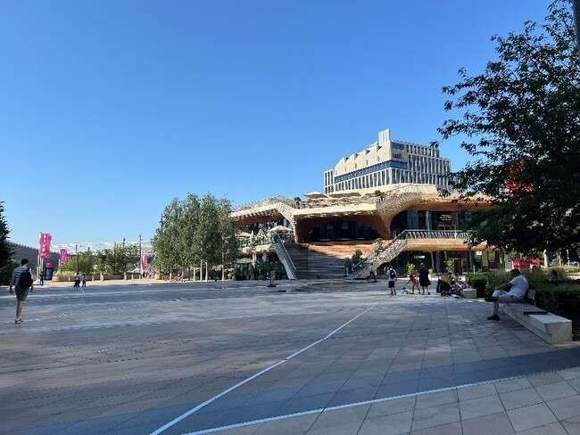 | You will arrive at Stratford Cross.
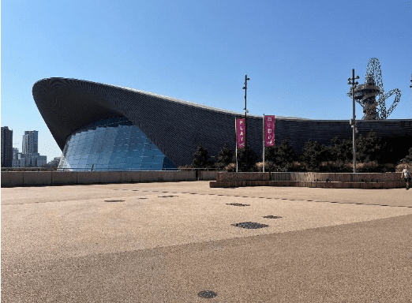 | Pass the Aquatics Centre on your  left on Stratford Walk.
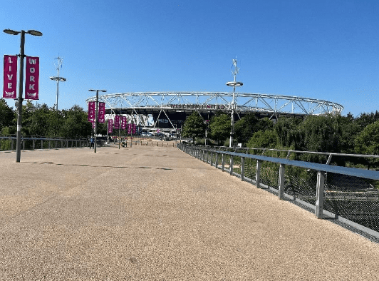 | Cross the bridge towards the  Stadium.
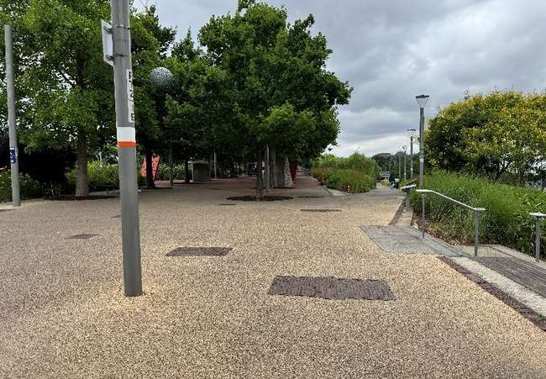 | After the bridge turn right onto the  path.
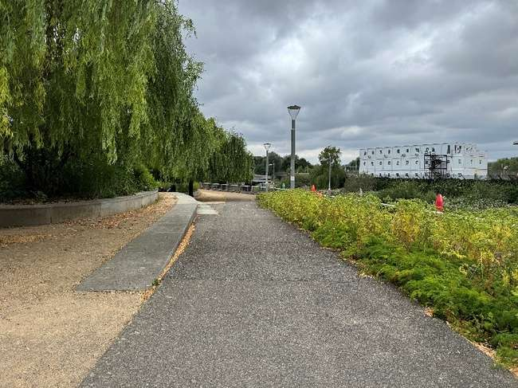 | Keep right to go down the ramp alongside the canal.
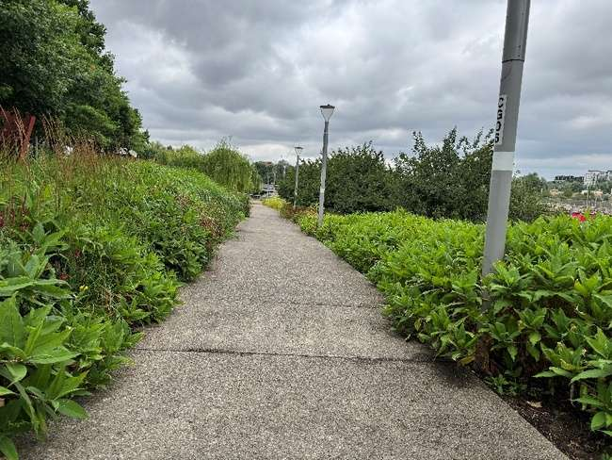 | Follow the path down to the end.
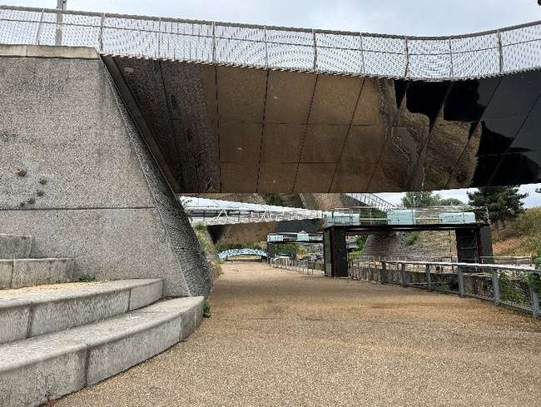 | The path will curve round to the left and you will arrive at the performance site for WaterKind.

