When Jazz Meets Hip Hop, Fragments Of Us- Dancing City
Route from Stratford Station, Station Street

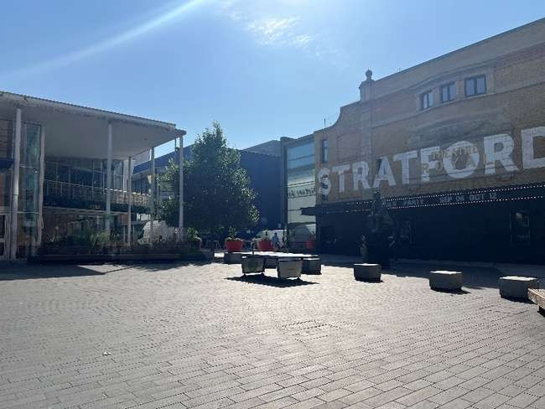 | Address:  Theatre Square Rooftop, Theatre Square, Stratford. E151BX  What 3 Words:  What3words ///foster.calms.they
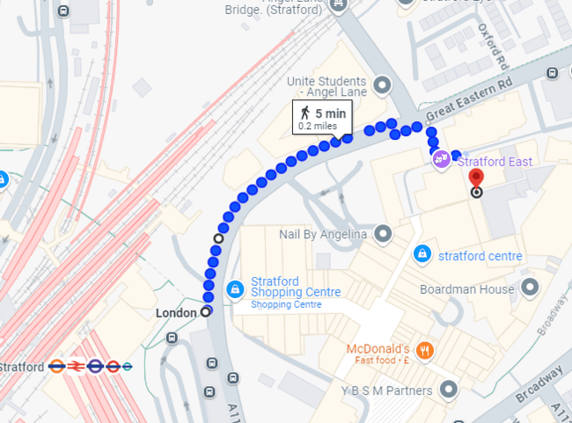

 | Transport  Stratford Station and Bus Station
 | Plan Your Journey:  Visit www.tfl.gov.uk

Route from Stratford Station, Station Street (opposite the bus station and Stratford Shopping Centre)

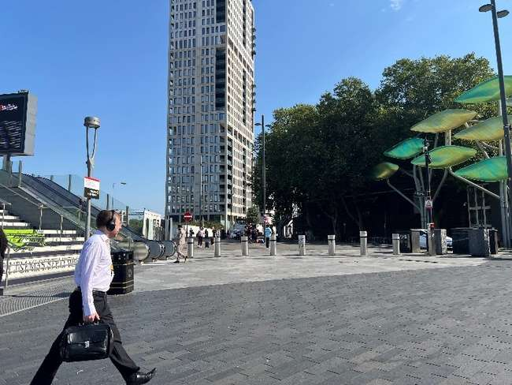 | Exit Stratford Station turning left onto Station Street, opposite the bus station and Stratford Shopping Centre.
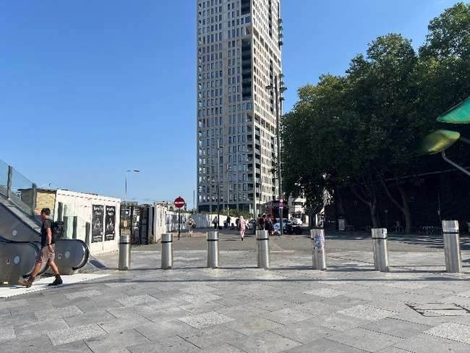 | Turn left onto Great Eastern Road.
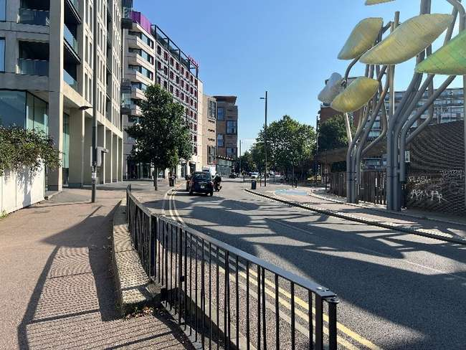 | Walk along Great Eastern Road.
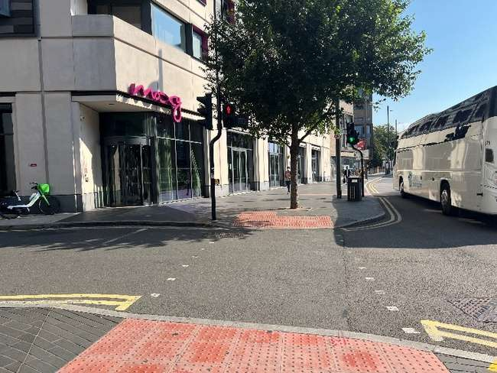 | Cross at a crossing continuing straight on Great Eastern Road.
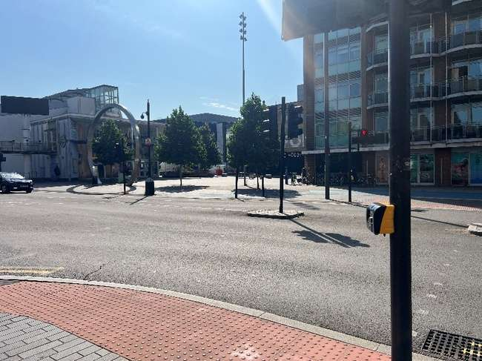 | At the traffic light junction turn right and cross Great Eastern Road.
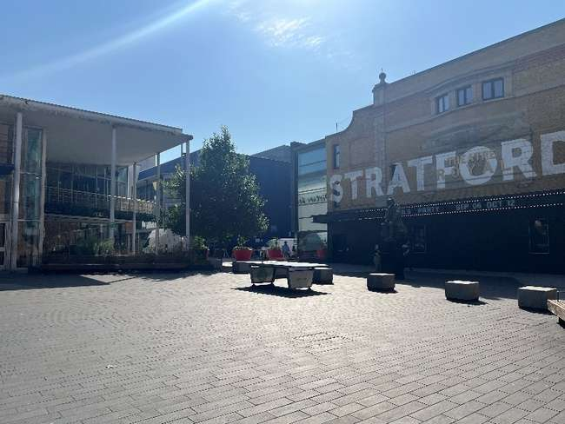 | Turn left onto Theatre Square and walk past Stratford East with the building on your right.
 | Walk through the planters towards Stratford Youth Zone.
 | The entrance will be between Stratford East and Stratford Youth Zone. There will be flags and volunteers.

