Jungle Boy
by Levan Peart

Live Outdoor Performance

Visual Guide
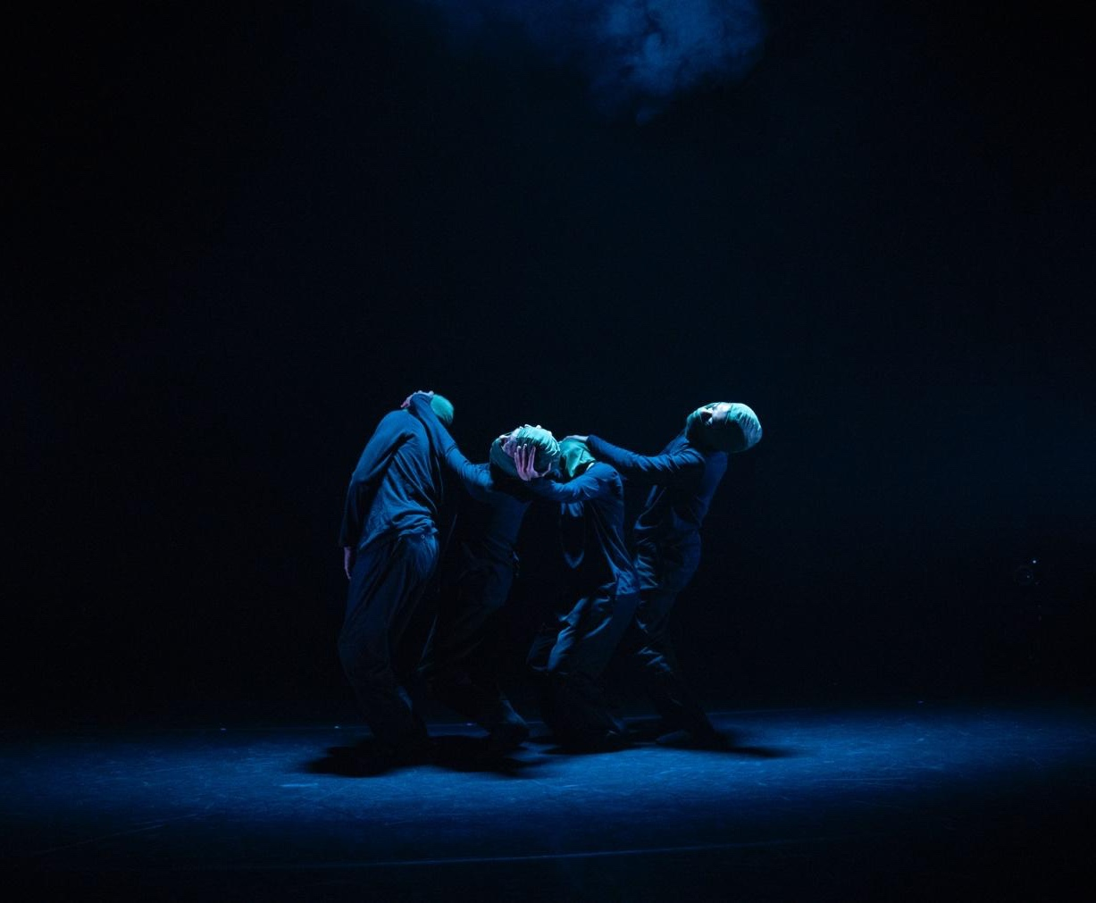

4 dancers in dark clothes and green balaclavas, standing in a line with their arms draped over eachother

What to Expect

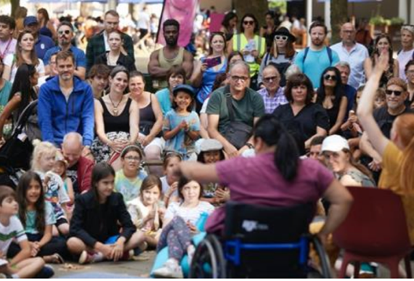 | Who is it for?  This show is suitable for all ages and is aimed at ages 16+
 | Dates and Times:  Saturday 6th September 2025  2pm, 4:15pm
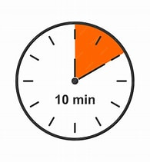 | Length of show:  10 minutes
   | Access:  - Speech Free
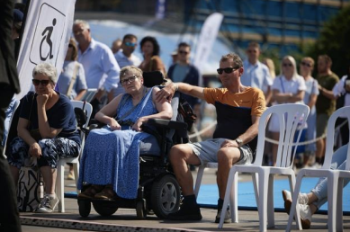 | Access Viewing Area for:  - Wheelchair users.  - Anyone who needs a seat.  - Companions.  - Anyone who needs it for access reasons.
 | Music and Sound:  The music score is played pre-recorded with a live Saxophone performance element
 | Content (if required)  Themes of mental health and emotional intensity
 | You are welcome:  ・Move around – just not on stage.  ・Make noise  ・Join and leave at any time
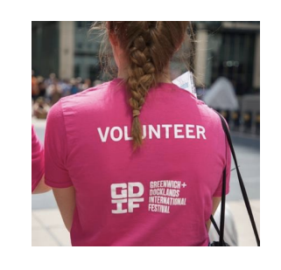 | Volunteers:  Friendly volunteers are there to help.  They will be wearing pink t-shirts.

About Jungle Boy

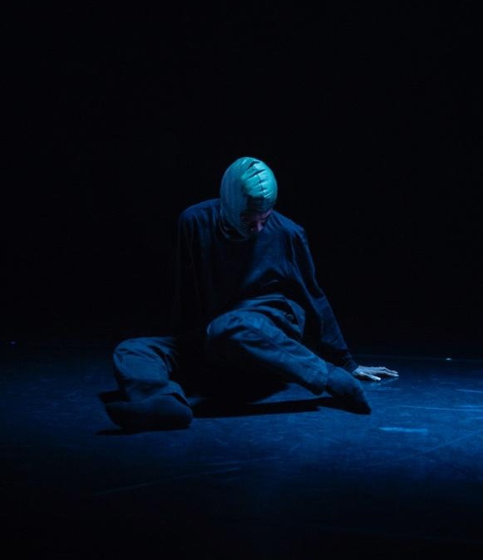 | Jungle Boy symbolises a return to nature, truth, freedom and grounded ancestral (family) expression.
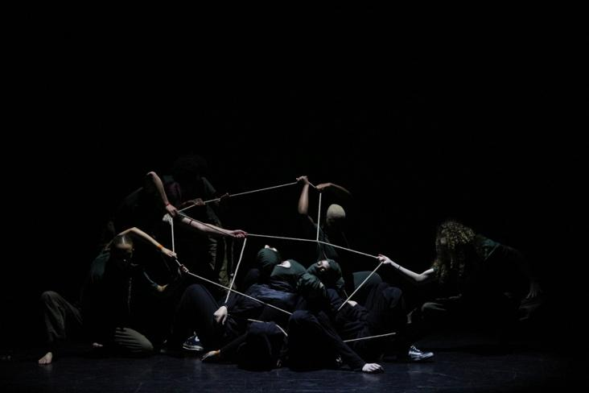 | Jungle Boy is inspired by experiences of mental health and neurodiversity within marginalised communities.
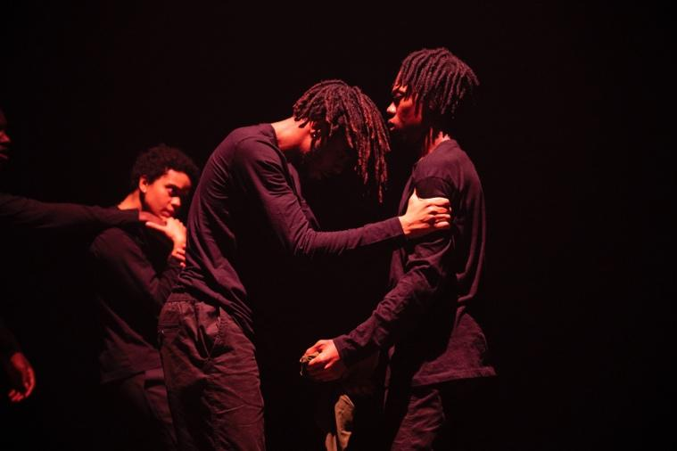 | The piece explores the journey to self-liberation (freedom) amidst societal restrictions (limitation)
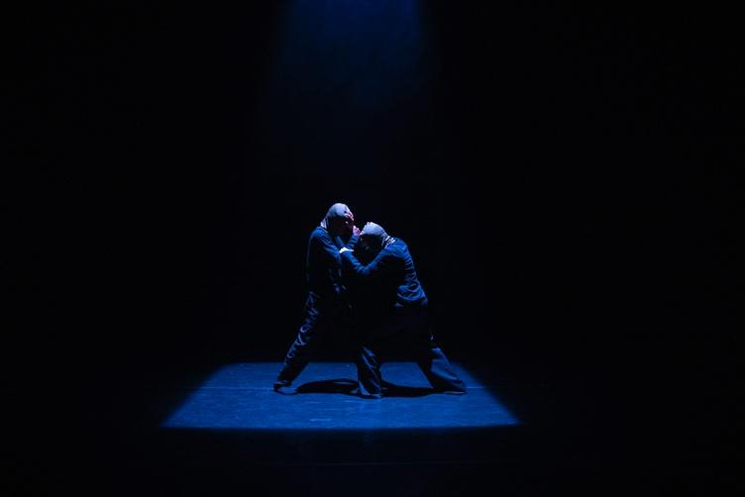 | Jungle Boy celebrates learning to move through the world with your natural authenticity (truth) and embracing your identity.
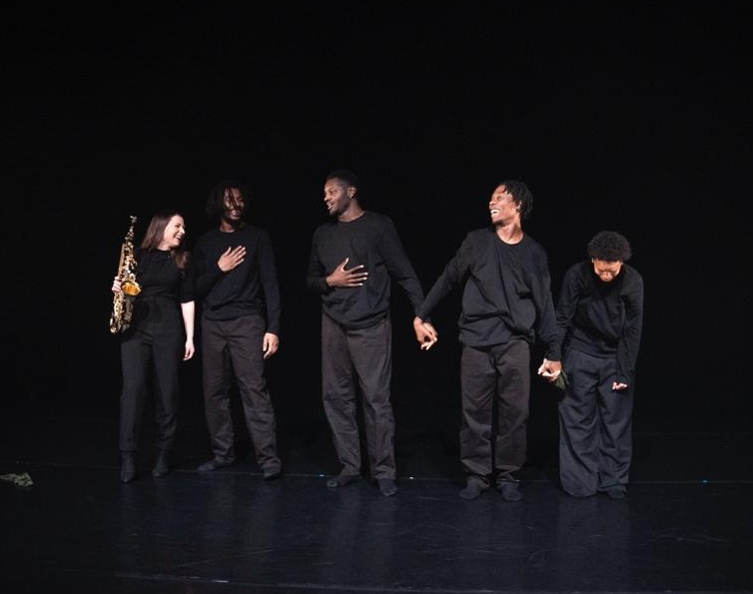 | The performance features local artists and encourages conversation around mental health, social mobility and resilience.

What happens in the show

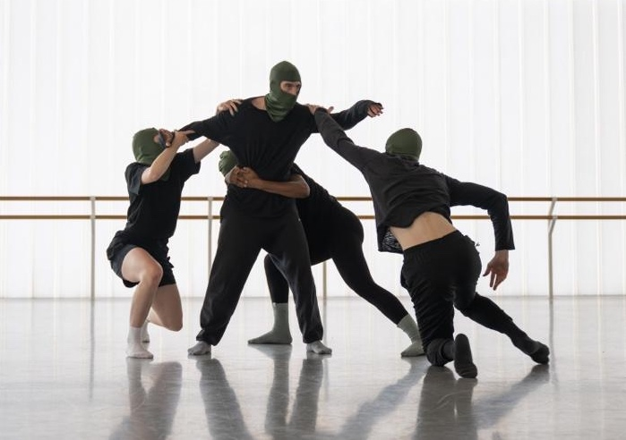 | Four dancers will perform
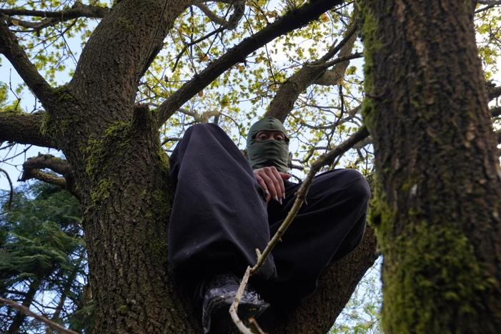 | They wear colourful dark green balaclava masks and black clothing.
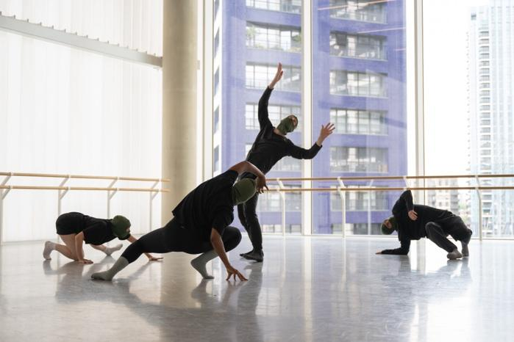 | The dancers begin centre stage, seemingly trapped or overwhelmed.
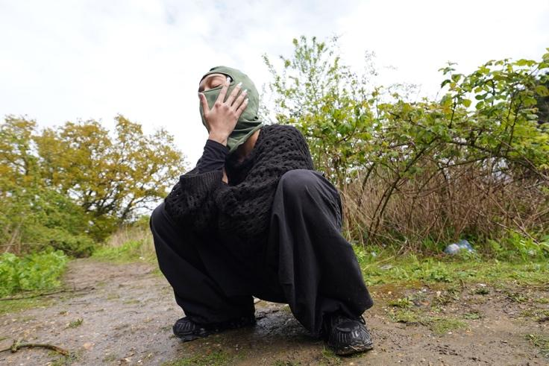 | Music builds as movement becomes more larger and bolder
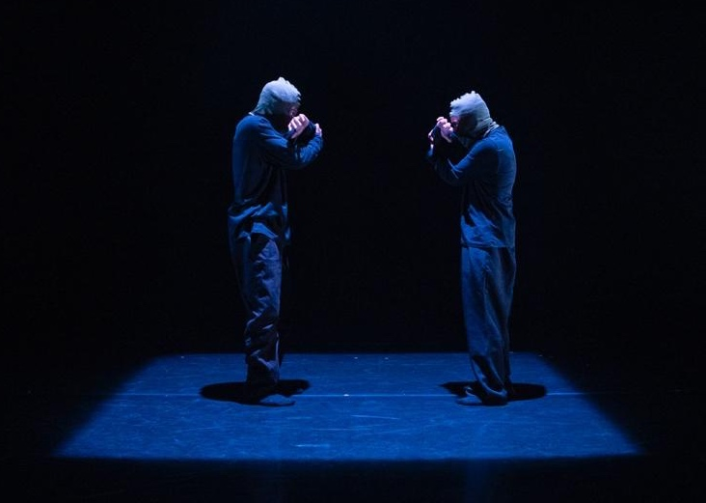 | Halfway through the performance, a live saxophonist appears and performs live alongside the dancers.
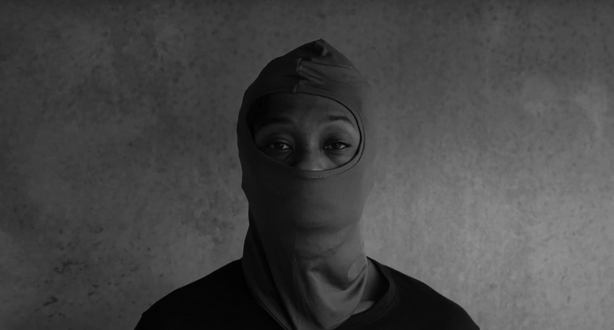 | The dancers will perform alone and in pairs, with moments of both contact and support.
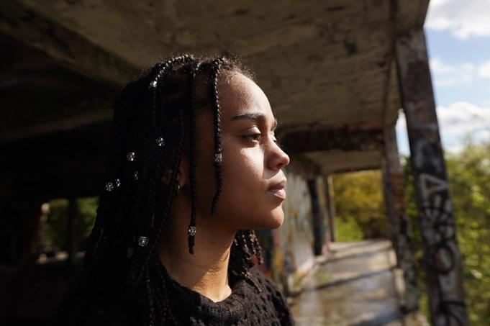 | At the end, the dancers remove their masks to celebrate their identity and community with movement.

Creative team

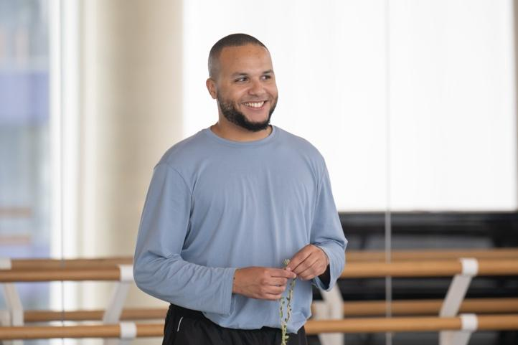 | Levan Peart  Creative Director & Choreographer
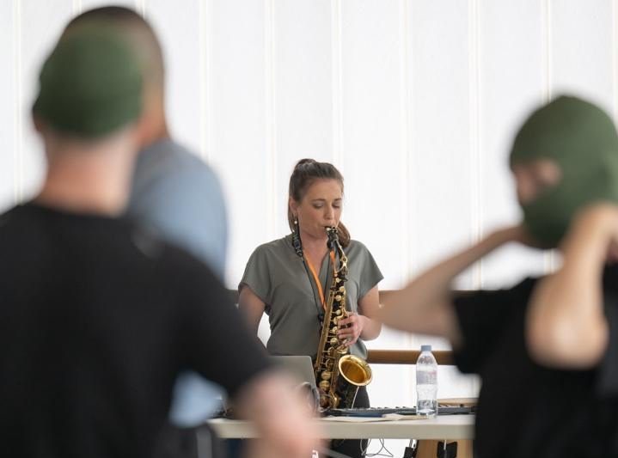 | Charlotte Harding  Music Composer &  Live Saxophonist Performer
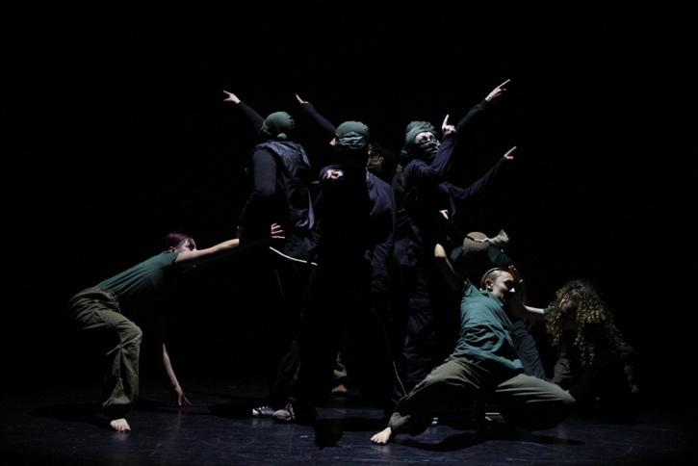 | - Jordanne Case  - Sophie Erika St. Cyr  - Lyndon Joshua Jasiah Oghenekaro  - Elijah Smith  Dance Artists
 | Photography by:  Levan Peart  Soph Bradbury  Amber Hunt  Brandon Anderson  Tytan  With special thanks to:  English National Ballet  Breakin’ Convention  The Capsule  University of East London

Find out more

 | Info about the company:  Jungle Boy by Levan Peart  Jungle Boy is the creative vision of Levan Peart: a filmmaker, choreographer, and cultural producer committed to platforming powerful, community-rooted stories. Blending dance, film, and lived experience, Levan’s work explores identity, social mobility, and personal transformation.  Jungle Boy serves as a vessel for self-expression, ancestral healing, and connection through movement and narrative.
 | Contact:  Evie Ayres-Townshend (Access Producer)  Email: access@festival.org  Call or text: 07899 893 935

