When Jazz Meets Hip-Hop
by UEL Dance Collective
Visual Guide

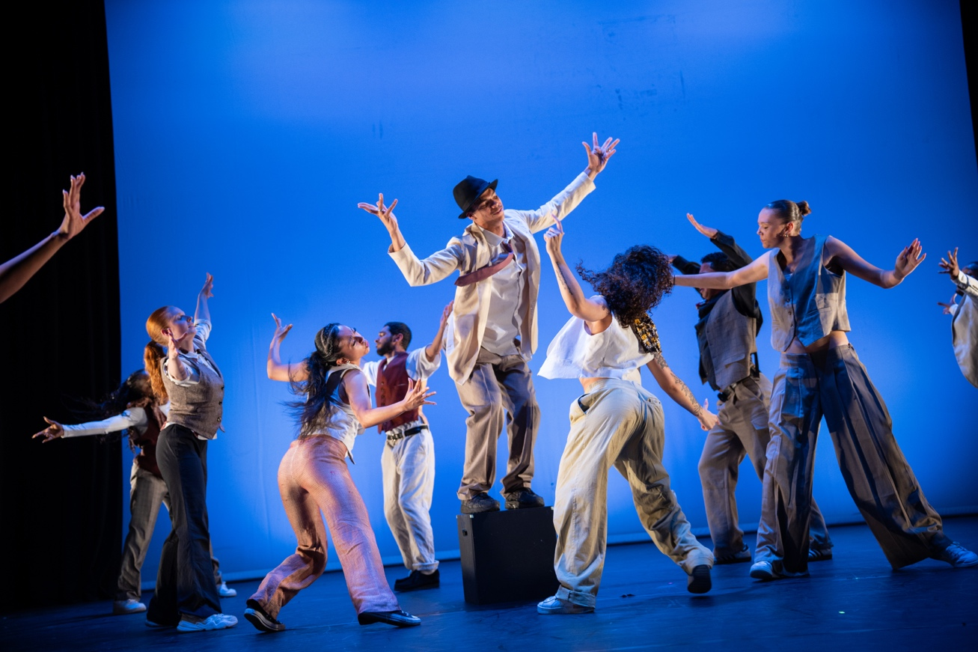

Twelve dancers blend jazz and hip-hop in a powerful, joyful celebration of music and community.

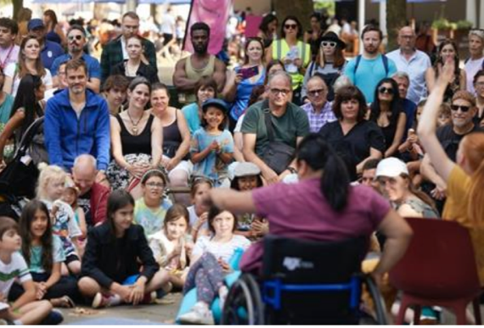 | Who is it for?  This show is made for adults and suitable for all ages.
 | Dates and Times:  Sat 6 September | 1.30PM & 3:00pm | Stratford Rooftop, Stratford Town Centre, E15 1BX
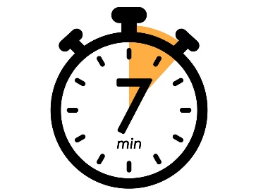 | Length of show:  6 minutes 30 seconds
   | Access:  - *please note* Entrance to this performance is through a gate 0.98 metres wide and up a slope with a 41.9 % incline at the steepest part  - There will be security and staff on the door who will check your bags on entry.  - The show is speech free
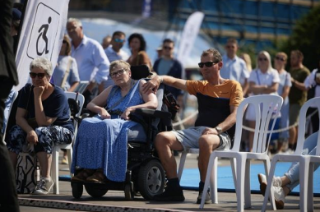 | Access Viewing Area for:  - Wheelchair users.  - Anyone who needs a seat.  - Companions.  - Anyone who needs it for access reasons.
 | Music and Sound:  The music is edited by Bismark Anobah. Expect a blend of Jazz and Hip-Hop music.
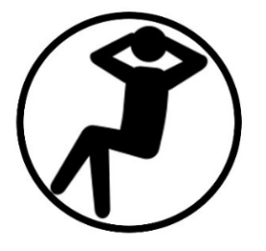 | You are welcome:  ・Move around – just not on stage.  ・Make noise  ・Join and leave at any time
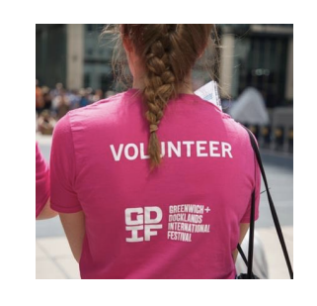 | Volunteers:  Friendly volunteers are there to help.  They will be wearing pink t-shirts.

About ‘When Jazz Meets Hip Hop’

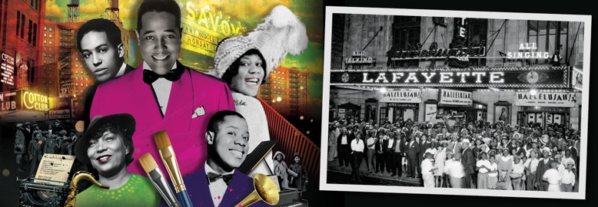 | When Jazz Meets Hip-Hop is a dance work inspired by the Harlem Renaissance and modern hip-hop culture.
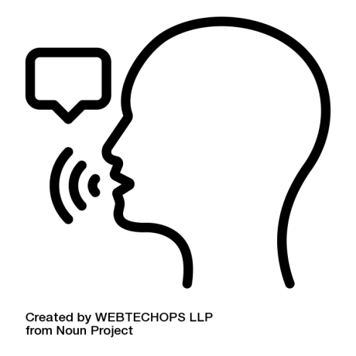 | Rebellion and Joy: Both genres represent the voice of the voiceless, bringing empowerment and joy.
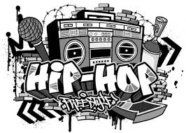 | Young Voices: The piece opens a dialogue for younger audiences to understand hip-hop’s rich roots and shows how jazz influences continue to shape hip-hop today.
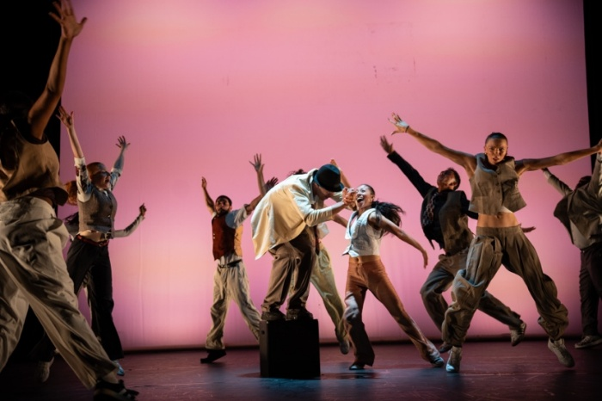 | Movement and motifs  You will see a variety of movement practices including Hip Hop, Swing jazz, Partner work, Gestural motifs connected to the use of musical instruments including trumpets are also evident.

What happens in the show

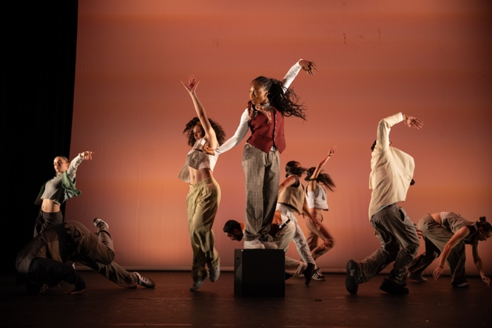 | - 12 performers, who are current students or recent graduates from the BA (Hons) Dance course at University of East London.
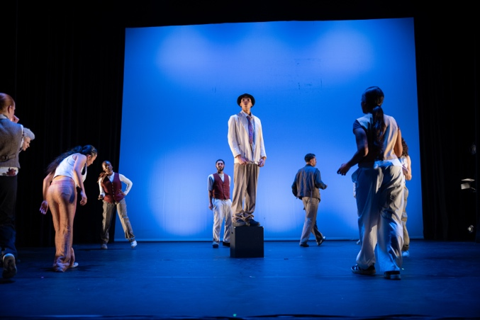 | - One block is placed centre stage before the piece begins. There are no projections or complicated sets —the focus is on movement and music.
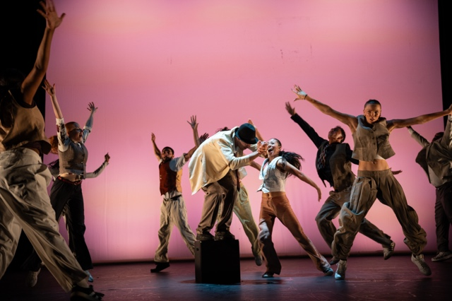 | The dancers’ costumes reference the vibrant colours and costume palettes from the Harlem Renaissance and Hip Hop. Costumes are supplied by Gideon Reeling
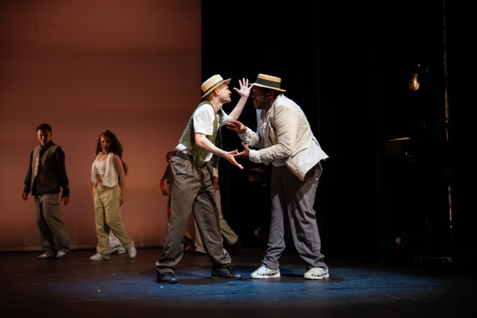 | There are numerous choreographic devices which you will see in the work including unison, duets, trios, canon, and formations.

Creative team

Jade Hackett  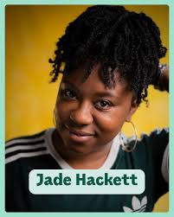 | Choreographer  Jade is a choreographer, actress, artistic director and movement director from east London.  She was soon able to blend her two greatest loves in theatre and dance by becoming a choreographer and movement director within these spaces.  She describes her own personal work as ‘dance activism’.
Bismark Anobah  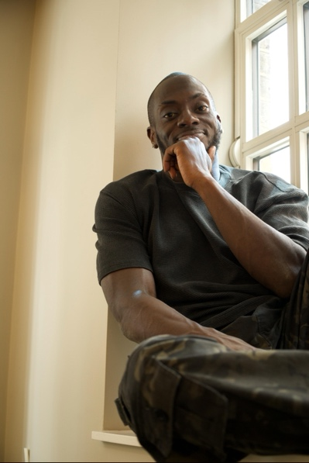 | Contributing choreographer & music editor  Bismark Anobah is a distinguished dance professional and adjudicator, currently serving as a judge for the International Dance Organization (IDO) and Hip Hop International (HHI) With a career spanning over two decades.
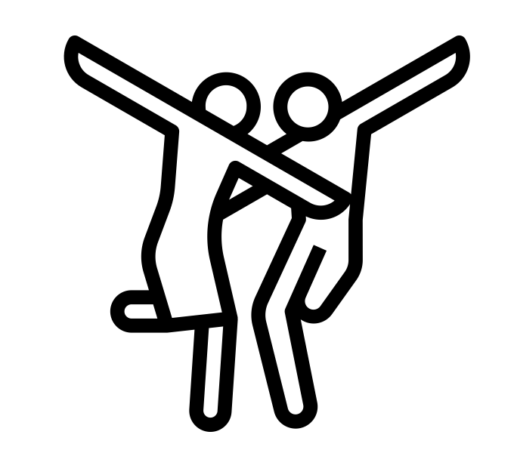 | Dancers  - Summer Bloomfield  - Kendice Collado  - Nathaniel Koakan  - Mariana Fonseca  - Aaliyah Gilkes-Brown  - Elliott Smith  - Gary Clarke  - Abe Taylor  - Tilly Holstead  - Izzy O'Sullivan  - Plamedie Kayeye  - Ethan Vitler

Find out more

 | Info about the UEL Dance Collective  The UEL Dance Collective was established in September 2015 to provide the BA (Hons) Dance (previously, Dance: Urban Practice) degree students with more performance opportunities. A different choreographer is contracted each term to audition and work with the student's and to give them an insight as to what it would be like to work in a professional dance company.  UEL Dance Collective playlist
 | Contact:  Email: access@festival.org  Call or text: 07899 893 935

